**Chapter 1:INTRODUCTION TO INNOVATION /INTERSHIP**

On the first day of the internship, we were guided with the knowledge about innovation of new technologies and new concepts or problem statements that were given by SIH (smart India hackathon). We were made to gain the Knowledge about what is innovation? What does innovation consist of? Basically, understanding what exactly innovation is. Hereby, let us understand the meaning of innovations:

**Innovation = Invention + exploitation**

Innovation is something new which is obtained by outcomes, which also consist of value. This involves a whole process of opportunity identification, ideation or invention to development, prototyping, and many more. But, entrepreneur -ship only needs to involve commercialization.

Its said that innovation comes about through new combinations made by an entrepreneur, resulting in

* A new product • a new process
* opening of new market
* new way of organizing the business
* new sources of supply

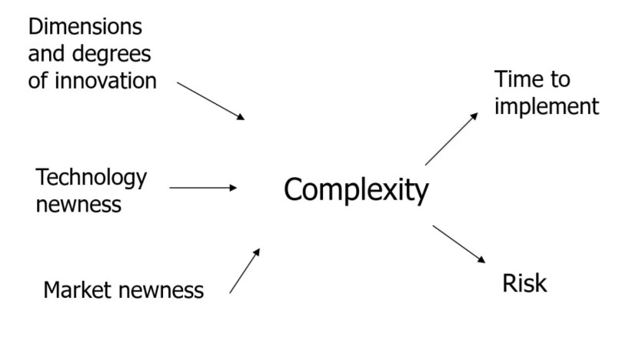

Innovation complexity 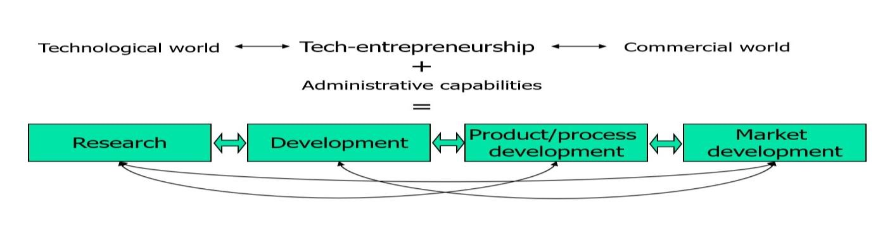 Basic model for innovation management is interactive

* 1. **Discussing and finalization of title/ topics of interest based on various problem statement with their respective guide**

TOPIC: Developing a software for dubbing videos from English to other Indian regional languages

Description: This challenge involves the development of software capable of dubbing videos from English to various Indian regional languages. The software should provide high-quality dubbing and synchronization to make video content more accessible and inclusive.

Everyone likes to watch movies or videos without subtitles. Even better if the movie is the language of their own

• A - Dubb is software that gives you an experience to enjoy a movie in your regional language. It will not only eliminate the pain to dub a movie/video indifferent languages but also saves a lot of time and money.

• What makes A - Dubb different from other software’s is that it will dub in the same voice of the original artist rather than a regional artist.

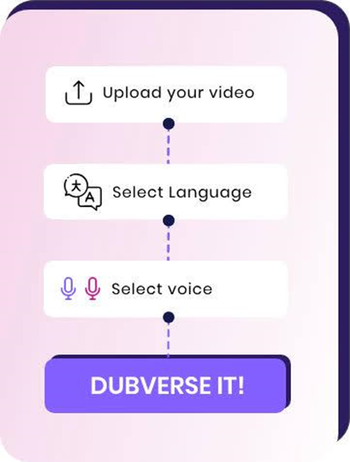

Fig 1.1 (a)

**Guides referred:**

* Wikipedia
* SlideShare

**Developing Software to Dub Video in Regional Languages**

* In spite of many languages being spoken in India, it is difficult for the people to understand foreign languages like English, Spanish, Italian, etc. The recognition and synthesis of speech are prominent emerging technologies in natural language processing and communication domains.
* People increasingly look to video as their preferred way to be better informed, to explore their interests, and to be entertained. And yet a video’s spoken language is often a barrier to understanding. For example, a high percentage of YouTube videos are in English but [less than 20% of the world's population speaks English](https://en.wikipedia.org/wiki/List_of_languages_by_total_number_of_speakers) as their first or second language. Voice dubbing is [increasingly being used](https://www.hollywoodreporter.com/tv/tv-news/netflix-s-global-reach-sparks-dubbing-revolution-public-demands-it-1229761/) to transform video into other languages, by translating and replacing a video’s original spoken dialogue. This is effective in eliminating the language barrier and is also a better accessibility option with regard to both literacy and sightedness in comparison to subtitles.
* The majority of video content is produced in English, leaving those who do not speak the language excluded from consuming it.

# Solution Overview

#### Dubbing Software:

We developed easy to use software that can convert English audio tracks into multiple regional languages like Hindi, Tamil, and more.

#### Accuracy and Quality:

Our software uses advanced machine learning models to ensure top-notch accuracy and quality of dubs at a faster pace.

#### Cost Effective:

Our solution provides high-quality dubs with reduced costs and increased flexibility for content creators, enabling them to cater to different regional audiences.

**Development Process:**

#### Design and Conceptualization:

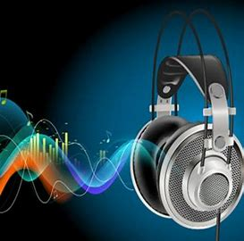

Fig:1.1(b)

We used agile methodologies to develop the software while following design thinking principles to ensure seamless user experience.

#### Collaboration:



Fig:1.1(c)

* Our software provides a scalable and cost-effective solution to the problem of dubbing videos in regional languages, making video content accessible to millions of people in India.
* With the collaboration of some ML coding languages we make this software implementation successfully to dub video to audio.

Testing and Implementation:

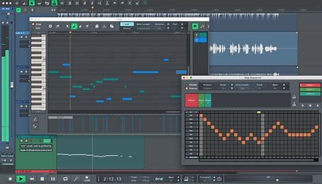

Fig:1.1(d)

Multiple iterations of testing and feedback from our users helped us improve the software and release it into production.

# Benefits:

#### High Quality Dubs:

Our software provides high-quality dubs that are easy to understand and watch.

#### Caters to Multiple Languages:

Our solution provides dubs in multiple regional languages, catering to a broader audience.

#### Lower Cost:

Our software is cost-effective and provides an alternative to expensive professional studios and services.

#### Increased Accessibility:

Accessible video content in regional languages can help bridge the digital divide and provide broader access to knowledge and information.

* 1. **RESEARCH PAPERS:**

|  |  |  |  |  |  |
| --- | --- | --- | --- | --- | --- |
| SL.no | year of publication | Author | Title of page | Methodology | Problems |
| 1. | 2018 | Utkarsh  Agrawal | Automated movie dubbing system (A dub) | Provide end-to-end translated movies/clips.  •The translated clips will retain the voices of original artists.  • Companies can save a lot of money by not hiring local artists.  • Also, auto-dubbing will save a lot of time and effort.  • The validations of translated/dubbed scripts will be done by professionals. | Loss of original actor’s performance and talent  Dubbing is a common practice in the world of film and television, but it can take away from the original actor’s performance. Dubbed actors often sound different than their real-life counterparts, as they are not delivering their own dialogue in an emotionally charged scenery. |
| 2. | 2013 | Antony P. J. | Machine Translation Approaches and Survey for Indian Languages | 1.The term MachineTranslation  is a standard name for computerized systems responsible for the production of translations from one natural language into another with or without human assistance  2.The literature shows that there have been many attempts in MT for English to Indian languages . | Dubbed audio can be of lower quality and difficult to understand  A final disadvantage of dubbing is that the audio quality may not always be as good as the original source material and can sometimes be difficult to understand. As a result, viewers may end up missing out on certain elements of the story or even entire lines of dialogue due to poor sound quality. |
| 3. | 2017 | Cliff Weitzman | Audio dubbing on video | Audio dubbing on video is a crucial element in the field of multimedia and broadcasting, essential in reaching a global audience. It refers to the process of replacing the original audio, usually dialogue, of a video with another set in a different language. | dubbed audio also presents an issue with syncing – often times dialogue will occur out of sync with the actors’ mouth movements, resulting in an unnatural viewing experience for audiences. For these reasons, it’s important for producers to take steps to ensure the highest possible sound quality when dubbing their films and shows in order to provide viewers with an enjoyable and engaging experience. |
| 4. | 2019 | 1.[Srikar Kashyap Pulipaka](https://www.researchgate.net/profile/Srikar-Kashyap-Pulipaka) | Machine Translation of English Videos to Indian Regional Languages using Open Innovation | In spite of many languages being spoken in India, it is difficult for the people to understand foreign languages like English, Spanish, Italian, etc. The recognition and synthesis of speech are prominent emerging technologies in natural language processing and communication domains. This paper aims to leverage the open source applications of these technologies, machine translation, text-to-speech . | Dubbing films or shows into another language can face challenges in matching lip movements, preserving cultural nuances, and maintaining the original emotional context. Sometimes, the translated dialogue might not fully capture the intended meaning, leading to a loss of authenticity or humor. Additionally, finding skilled voice actors who can convey the same emotions and tone as the original actors can also be a hurdle. |
| 5 | 2020 | [B. S. Harish](https://link.springer.com/article/10.1007/s42452-020-2983-x#auth-B__S_-Harish-Aff1) &  [R. Kasturi Rangan](https://link.springer.com/article/10.1007/s42452-020-2983-x#auth-R__Kasturi-Rangan-Aff1) | A comprehensive  Survey on Indian regional language processing | Any language that has evolved naturally in humans through its usage over the time is called natural language. In this survey, the various approaches and techniques contributed by the researchers for Indian regional language processing are reviewed. The tasks like machine translation, Named Entity Recognition, Sentiment Analysis and Parts-Of-Speech tagging are reviewed with respect to Rule, Statistical and Neural based approaches. The challenges which motivate to solve language processing problems are presented. The sources of dataset for the Indian regional languages are described. | Tokenization of the text. Some of the regional languages dont have common delimiters like white space or punctuations.  Language structure i.e. order of the words in the sentences will differ from one language to another  Ambiguity in translation or transliteration of regional language words. |
| 6. | 2021 | Varshul Gupta  Anuja Dhawan | Dubbing video content in real time | Dubbing involves several steps. First, a translated script is created, aiming to match the lip movements as closely as possible while retaining the essence of the original dialogue. Then, skilled voice actors record the translated lines in a studio. Sound engineers synchronize these recordings with the visuals, adjusting timing and pacing to match the lip movements. | Dubbing videos from English to other regional languages presents specific challenges. Beyond issues with lip-syncing and cultural nuances, finding voice actors fluent in both languages and capable of delivering performances that resonate with local audiences can be challenging. Moreover, certain idiomatic expressions or wordplay in English might not directly translate into other languages, |
| 7. | 2023 | [Wilson Wongso](https://ieeexplore.ieee.org/author/37089192120)  [Brandon Scott Buana](https://ieeexplore.ieee.org/author/37089942723)  [Ananto Joyoadikusumo](https://ieeexplore.ieee.org/author/37089943516) | Many to many multilingual translation model for languages of indonesia | Indonesia is home to over 700 languages and most people speak their respective regional languages aside from the lingua franca. In this paper, we focus on the task of multilingual machine translation for 45 regional Indonesian languages and introduced Indo-T5 which leveraged the mT5 sequence-to-sequence language model as a baseline. | Sound engineers synchronize these recordings with the visuals, adjusting timing and pacing to match the lip movements. Finally, quality checks are done to ensure coherence and accuracy before the dubbed version is released. This process requires precision, linguistic expertise, and attention to detail to maintain the integrity of the original content in a new language |
| 8. | 2020 | Frederic Chaume | Dubbing | Dubbing involves linguistic, cultural, technical and creative team effort for the translation, adaptation and lip synchronisation of an audiovisual text. Research on dubbing has grown exponentially, in parallel with scholarship in audiovisual translation in general, ushering in a wide array of works in professional and sociological studies, linguistic studies, descriptive studies, ideological studies, cognitive studies and case studies in the new field of audiovisual translation | Adapting dialects or regional accents in dubbing might be challenging, affecting the authenticity of the translation.  Risk of Mistranslation: Errors in translation or interpretation during the dubbing process can result in inaccuracies and misunderstandings.  Dubbed versions might not be as widely available as the original content with subtitles, reducing accessibility |
| 9. | 2022 | [Aarati H. Patil](https://ieeexplore.ieee.org/author/37089391281); [Snehal S. Patil](https://ieeexplore.ieee.org/author/37089391253); [Shubham M. Patil](https://ieeexplore.ieee.org/author/37089391250); [Tatwadarshi P. Nagarhall](https://ieeexplore.ieee.org/author/37086269038)i | Real time machine translation system between Indian languages | Language understanding is one of those perpetual challenges which has dogged research from many decades. As a means of connecting with others, but communication is not limited to a single language. India contains around 121 different languages. As a result, there is a linguistic barrier. Natural Language Processing is the process of developing a communicational interface between machines and humans. | Script Adaptation: Translating and adapting scripts can be challenging, potentially altering the intended meaning or message.  Limited Availability: Dubbed versions might not be as widely available as the original content with subtitles, reducing accessibility.  Audience Preference: Some viewers prefer subtitles as they maintain the authenticity of the original language and performances |
| 10 | 2020 | [Ravinder Kumar](https://link.springer.com/article/10.1007/s11831-020-09449-7#auth-Ravinder-Kumar-Aff1)  [Inderveer Chana](https://link.springer.com/article/10.1007/s11831-020-09449-7#auth-Inderveer-Chana-Aff2)  Mukaan singh | Machine Translation system for Indian Languages | With the advancement in computer language technology in a multilingual country like India, numerous linguistics require technology for translation. It aids in research for ancient languages like Sanskrit, Tamil, Telugu, Malayalam to be available for society. machine translation is one of its essential areas. It plays a signifcant role in breaking the language barrier and facilitating inter-lingual. | Dubbing might not be economically viable for all regional markets, limiting the availability of content.  Educational Value: Subtitles allow viewers to learn the original language, providing an educational aspect that dubbing does not offer.  The challenge in this communication process arises with the restriction that language inflicts both at word and sentence level. |

* 1. **Supporting Software and its comparisons**

**1.What is dubbing Software?**

Dubbing software enables content creators and filmmakers to dub their videos with professional quality audio and video dubbing. Dubbing is useful for localizing the audio in video content to audiences that speak different languages.

**2.Supporting software’s for dubbing videos:**

1.Wavel-Wavel is an Al Studio that offers online video editing experience. Scaling videos 11X FASTER by generating natural sounding voices

2.Filmora- A video editor for all creators. Craft new worlds by layering clips and using simple green screen effects.

3.Adobe Audition-A professional audio workstation. Create, mix, and design sound effects with the industry’s best digital audio editing software.

4.Audacity-Free, open source, cross-platform audio software. Audacity is an easy-to-use, multi-track audio editor and recorder for Windows, macOS, GNU/Linux and other operating systems.

5.VideoDubber-AI-powered video translation, dubbing, voice cloning and text-to-speech services. Scale with us to 30+ languages to 10x your audience size effortlessly!

**3.How to Choose the Right Dubbing Software**

Selecting the right dubbing software will depend on your specific needs and preferences.

* The first step is to determine what type of dubbing you plan to do. Are you creating a podcast, adding voice-over to a video, or creating an audio book? This will help narrow down your options. Different types of dubbing software may be better suited for different types of projects.
* Next, consider the features each program offers. For example, how many tracks are available? Does the program have sound effects or background music options? What type of editing tools does it include? Do you need support for multiple languages or formats? Make sure that any desired features are available with the software before making your decision.
* Finally, compare prices and read reviews from other users who have tried out the software before. Reading user feedback can give you valuable insight into potential limitations or bugs in the program and how easy it is to use. Once you've found a few promising programs that meet your needs and budget, take some time to test them out yourself so that you can make an informed decision about which one is best for your project.
* Compare dubbing software according to cost, capabilities, integrations, user feedback.

**4.Advantages:**

* Increased Efficiency: Dubbing software increases efficiency by automating the process of creating multiple recordings from a single master audio file. This makes it easier and faster for audio engineers to create multiple versions of a project without having to manually mix each one.
* Improved Quality: Dubbing software also has the potential to improve the quality of recordings, as it can be used to apply effects such as equalization, compression, and reverb to get the desired sound.
* Reduced Costs: Since dubbing software streamlines the creation process and reduces the need for additional hardware or personnel, it can save time and money on projects.
* More Control over Final Product: Dubbing software allows audio professionals more control over their final product, enabling them to make quick adjustments if needed. They can also preview their work before committing to a final version, ensuring that all errors have been corrected.
* Multi-language Capability: With dubbing software, you can easily record or recreate audio in different languages so that your project is
* Versatility: Dubbing software can be used for a variety of applications, from creating video games to creating soundtracks for films and television shows

**Disadvantages:**

* Lip Sync Issues: Dubbing may not perfectly match the lip movements of the actors, leading to a disconnect between audio and visual elements.
* Loss of Authenticity: Original performances and nuances in language or tone may be lost, impacting the authenticity of the content.
* Cultural Misinterpretation: Dubbing can sometimes alter cultural references or nuances, potentially leading to misinterpretation or loss of intended meaning.
* Voice Mismatch: The dubbed voice might not suit the original actor's appearance or character, affecting the overall viewing experience.
* Quality Variation: Dubbing quality can vary, and poorly executed dubbing may result in a distracting viewing experience.
* Emotional Impact: Dubbed voices may not convey the same emotional depth as the original performances, diminishing the impact of dramatic scenes.
* Limited Availability of Voice Talents: Finding suitable voice actors for dubbing can be challenging, leading to a restricted pool of available talents.
* Technical Challenges: Achieving seamless synchronization between dubbed audio and video can be technically challenging, especially in complex scenes.
* Loss of Original Language Experience: Dubbing eliminates the opportunity for viewers to experience the original language and its cultural nuances.

**1.4 Methodology and related Block diagram/Flowchart**

1. **Machine Learning approach**

Video dubbing using machine learning involves automatic transcription and translation of the original audio. Machine learning models can generate new audio tracks in the target language or use text-to-speech synthesis. The generated audio is then synchronized with the video through lip movement analysis. Quality assessment and adjustments may be necessary.

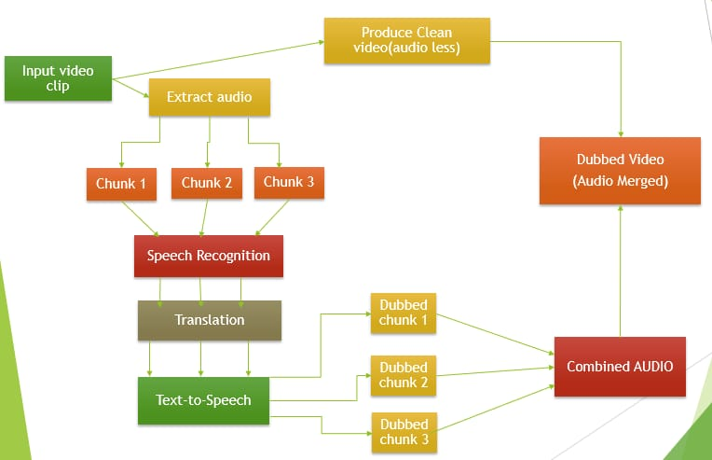

Fig:1.4(a)

* **Speech Recognition:**

- Utilize a pre-trained speech recognition model to convert English audio in the video into text.

- Popular libraries like Google's Speech Recognition or cloud services like Google Cloud Speech-to-Text can be employed.

**1. Selecting a Speech Recognition Library:**

- Choose a suitable speech recognition library based on your project requirements. Google's Speech Recognition is a user-friendly option for Python developers, offering pre-trained models for English.

**2. Installing the Library:**

- Install the chosen library using the appropriate package manager. For Google's Speech Recognition in Python, you can use pip:

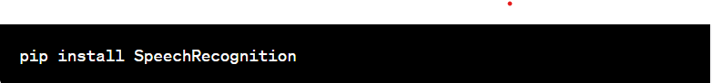

**3. Importing the Library:**

- In your Python script, import the SpeechRecognition library:



**4. Loading the Audio File:**

- Read the audio file containing English speech that you want to transcribe. Supported formats typically include WAV, MP3, or other common audio formats.



**5. Initializing the Recognizer:**

**-** Create an instance of the Recognizer class provided by the library:



**6. Speech Recognition Process:**

- Use the recognizer to perform the speech-to-text conversion. This involves reading the audio file and converting it into text:

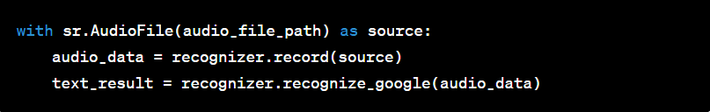

**7. Handling Exceptions:**

**-** Implement error handling to manage potential issues, such as audio file not found or recognition errors:

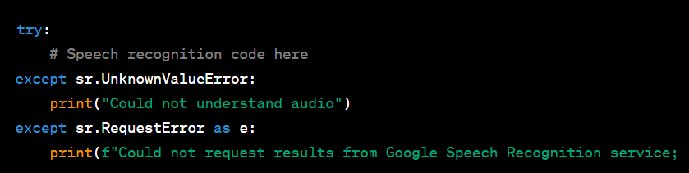

**8. Extracted Text Result:**

- Access the transcribed text from the `text_result` variable:



**9. Transcribing with Cloud Service:**

**-** Use the cloud service to transcribe audio from a file:



**10. **Accessing Cloud Results:\*\***

- Extract the transcribed text from the cloud service response:

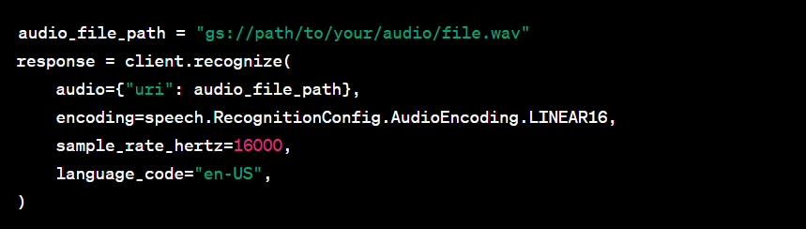

* **Translation:**

- Apply a machine translation model to translate the English text into the target language.

- Transformer-based models such as Google's Transformer or OpenNMT can handle complex language structures.

**Detailed explanation of the "Translation" step in video dubbing, focusing on applying a machine translation model:**

**1. Choosing the Machine Translation Model:**

- Select an appropriate machine translation model based on the target language and specific requirements of your video dubbing project. While there are various machine translation models available, transformer-based models are widely used for their ability to handle complex language structures.

**2. Preprocessing the English Text:**

- Prepare the English text obtained from the previous step (speech recognition) for translation. Ensure that the text is cleaned and formatted to improve the quality of the translation. This may involve removing unnecessary punctuation or special characters and splitting the text into sentences or segments.

**3. Selecting a Transformer Model:**

- For English to another language translation, transformer models like Google's Transformer or OpenNMT are suitable choices. These models have been pretrained on large multilingual corpora and are capable of handling various language pairs effectively.

**4. Loading the Pretrained Model:**

- Utilize libraries like Hugging Face Transformers or TensorFlow's Seq2Seq for loading pretrained transformer models. These libraries provide easy access to a wide range of transformer-based models.

**5. Performing Translation:**

- Feed the preprocessed English text into the selected transformer model for translation. The model will generate translations in the target language. Here's an example using Hugging Face's Transformers library:

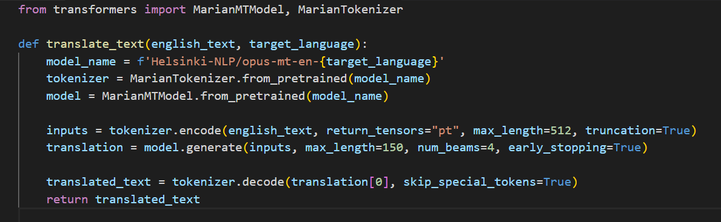

**6. Postprocessing the Translation:**

- After translation, it's essential to postprocess the translated text to ensure coherence and readability. This may involve adjusting word order, handling idiomatic expressions, and making minor corrections for context.

**7. Quality Assessment:**

- Implement quality assessment metrics or human reviewers to evaluate the accuracy and fluency of the translation. Metrics like BLEU score and human evaluation can be used to measure the translation quality.

* **Voice Synthesis:**

- Use a text-to-speech (TTS) model to convert the translated text into synthesized speech in the target language.

- Tacotron and WaveNet are examples of TTS models that can generate natural-sounding speech.

**Detailed explanation of the "Voice Synthesis" step in video dubbing, including the use of text-to-speech (TTS) models:**

**1. Selecting a Text-to-Speech (TTS) Model:**

- Choose an appropriate TTS model that can generate natural-sounding speech in the target language. TTS models have evolved significantly in recent years, and two popular choices are Tacotron and WaveNet.

**2. Setting Up the TTS Model:**

- Depending on your choice of TTS model, you may need to install and configure the necessary libraries and dependencies. For Tacotron and WaveNet, you can use the TensorFlow implementation, which can be found on GitHub.

**3. Loading the Pretrained TTS Model:**

- Download or load a pretrained Tacotron and WaveNet model. You can find pretrained models and weights on platforms like GitHub, or use libraries like TensorFlow to access them.

**4. Processing Translated Text:**

- Prepare the translated text obtained from the previous step (translation) for voice synthesis. Ensure that the text is correctly formatted, and consider segmenting it into smaller units, such as sentences or phrases, to improve the synthesis quality.

**5. Voice Synthesis with Tacotron:**

- If you're using the Tacotron model, feed the processed text into the Tacotron model to obtain mel spectrograms, which represent the acoustic features of the speech. Here's an example using a Tacotron 2 implementation in TensorFlow:



**6. Voice Synthesis with WaveNet:**

- Once you have the mel spectrograms, you can use the WaveNet model to convert them into natural-sounding speech waveforms. Here's an example using WaveNet in TensorFlow:

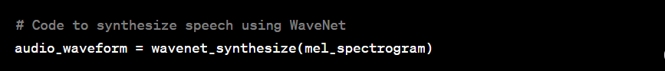

**7. Quality Assessment:**

- Evaluate the synthesized speech for naturalness, fluency, and clarity. Listen to the generated speech and employ objective metrics like Mean Opinion Score (MOS) if necessary to assess quality.

* **Synchronization:**

Align the synthesized speech with the original video by considering lip movements and natural pauses.

Use techniques like forced alignment or advanced lip synchronization models to achieve accurate synchronization.

**Detailed explanation of the "Synchronization" step in video dubbing, which involves aligning the synthesized speech with the original video:**

**1. Import Original Video and Synthesized Speech:**

- Start by loading the original video and the synthesized speech (audio) generated in the previous steps. You should have both the video and audio files ready for synchronization.

**2. Lip Movement and Phoneme Analysis:**

- Analyze the original video to identify key features, such as lip movements and phoneme transitions (visually distinguishable mouth shapes associated with speech sounds). This step is crucial for achieving accurate lip synchronization.

**3. Forced Alignment (Phoneme-Level Synchronization):**

- Use forced alignment techniques to synchronize the synthesized speech with the video at the phoneme level. Forced alignment tools like Penn Forced Aligner or Montreal Forced Aligner align phonemes in the audio with corresponding visual cues in the video. This ensures that the mouth movements match the speech.

**4. Frame-Level Alignment:**

- Implement frame-level alignment techniques to ensure that the speech and video are accurately synchronized. This involves mapping each frame of the video to specific timestamps in the audio.

**5. Handling Natural Pauses:**

- Identify natural pauses in the speech and video, such as pauses between sentences or phrases. Adjust the synchronization to allow for these pauses, ensuring that the dubbing sounds natural.

**6. Advanced Lip Synchronization Models (Optional):**

- Consider using advanced lip synchronization models, which use deep learning techniques to predict the precise lip movements for a given audio input. These models are trained on large datasets of videos and their corresponding speech. They can be more accurate in matching lip movements to speech, resulting in a more lifelike dubbing.

**7. Visual Feedback and Manual Adjustment:**

- Visually review the synchronized video to check for any misalignments or artifacts. Manually adjust the synchronization if necessary, particularly for cases where automated methods might not capture subtle nuances.

**8. Iterative Refinement:**

- Continuously refine the synchronization process based on feedback and quality assessment. Consider user feedback and make improvements as needed to achieve the highest level of accuracy and naturalness.

**9. Export the Synchronized Video:**

- Once you are satisfied with the synchronization, export the final video with the synchronized audio. Make sure the video file format and settings are appropriate for your intended distribution platform.

1. **Traditional approach**

**Dubbing a video using traditional methods typically involves the following steps:**

**1. Translation and Script Preparation:** Translate the original script and dialogue from the source language to the target language. Make sure the translated script matches the timing and lip movements of the original video as closely as possible.

**2. Voiceover Recording:** Hire voice actors who are native speakers of the target language. They will read the translated script while watching the original video. Ensure that the voice actors' timing matches the lip movements of the original actors.

**3. Audio Editing:** Edit the voiceover recordings to match the timing and pace of the original video. This may involve cutting, splicing, and synchronizing the audio with the video.

**4. Mixing and Sound Design:** Balance the audio tracks, add background music, sound effects, and adjust audio levels for clarity and coherence.

**5. Video Editing:** Replace the original audio track with the dubbed audio. Ensure that the dubbed audio is properly synchronized with the video.

**6. Quality Control:** Review the dubbed video to ensure that the lip-sync is accurate, the audio quality is good, and there are no noticeable discrepancies.

**7. Exporting and Distribution:** Once you are satisfied with the dubbed video, export it in the desired format and resolution. You can then distribute the dubbed video to your intended audience.

* The traditional method of dubbing is labor-intensive and often requires professional expertise in translation, voice acting, audio editing, and video editing. It is commonly used in the film and television industry to create high-quality localized versions of content for different regions.

**1.5 Discussing its Implementation (via method one – using machine learning):**

1. Using API
2. Collecting data and training a Machine Learning model to dub the video

* **Using API**

Using an API for video dubbing is not always a requirement, but it can offer several advantages, depending on our specific needs and constraints. Here are some reasons why we might consider using an API for video dubbing:

**1. Efficiency and Speed:** APIs can automate and streamline the dubbing process. They can handle tasks like transcription, translation, and text-to-speech synthesis more quickly and efficiently than manual methods. This can save you a significant amount of time, especially when dealing with large volumes of content.

**2. Accuracy:** Machine learning-based APIs can provide accurate transcriptions, translations, and synthesized speech. They are less prone to human errors and can handle multiple languages and accents, which may be challenging for manual dubbing.

**3. Cost-Effectiveness:** In some cases, using an API can be cost-effective, especially for smaller projects or when you don't have access to a team of professional voice actors and audio engineers. API usage typically involves pay-as-you-go pricing, which can be cost-efficient.

**4. Consistency:** APIs can provide a consistent quality of dubbing across multiple videos. This is important for maintaining a high standard of content quality, which can be challenging to achieve with manual dubbing.

**5. Scalability:** APIs can easily scale to handle a large number of videos, making them suitable for projects with high volume requirements.

**6. Multilingual Support:** Many APIs support multiple languages, making it possible to dub content into various languages without the need for multilingual voice actors.

**7. Ease of Integration:** Most APIs come with software development kits (SDKs) and libraries that make it relatively easy to integrate their services into your applications or workflows.

* **Training a Machine Learning model to dub the video**

Video dubbing using Machine Learning (ML) is not easy, and it is a complex and technically challenging task.

This example is for educational purposes and is highly simplified.

**we'll use the following libraries:**

- `Speech Recognition` for automatic speech recognition (ASR).

- `pydub` for audio processing.

- `moviepy` for video processing.

- `gTTS` (Google Text-to-Speech) for text-to-speech synthesis.

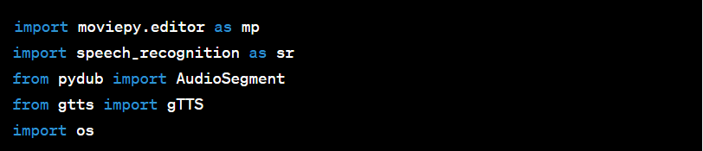

Follow Instructions as mentioned in the code below

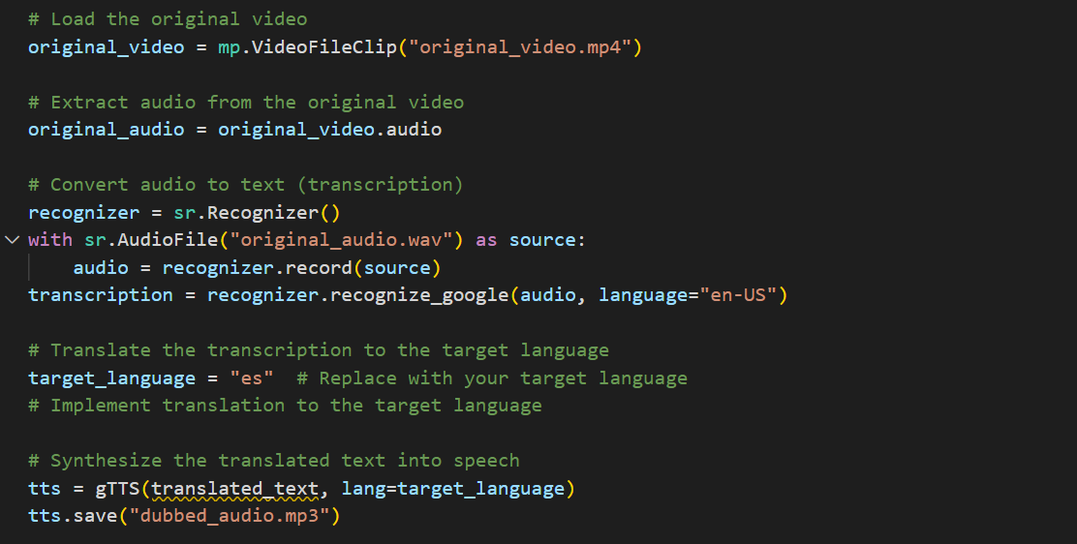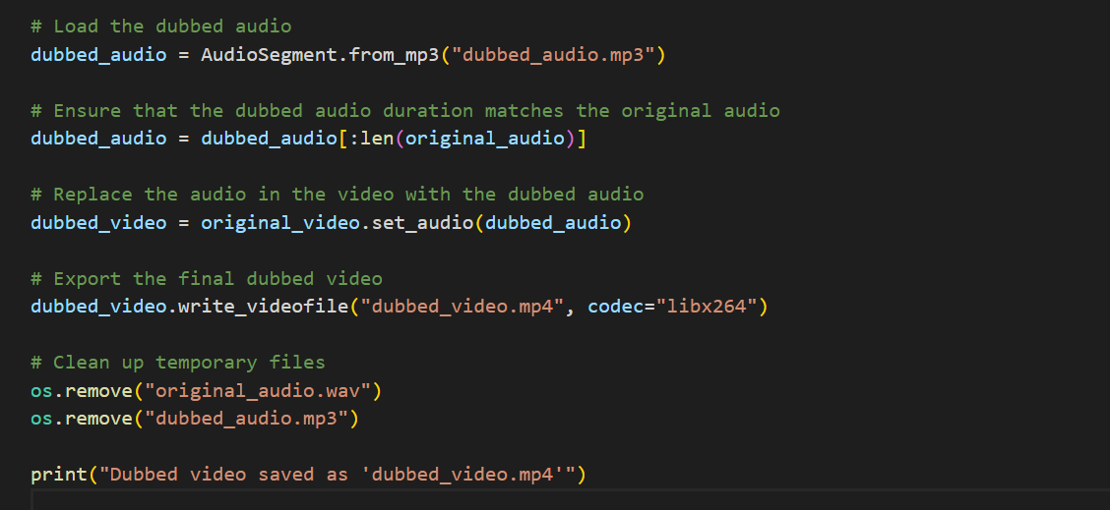

* Note that the above code is oversimplified, Further details of the code requires Assistance from a Machine learning Engineer

**1.6 Internship Conclusion**

Overall, this internship has been an excellent and rewarding experience. I can conclude that there have been a lot I’ve learnt from my work. Needless to say, the technical aspects of the work I’ve done are not flawless and could be improved provided enough time. As someone with no prior experience with this concpect whatsoever I believe my time spent in research and discovering it was well worth it and contributed to finding an acceptable solution to build a fully functional service. Two main things that I’ve learned the importance of are time-management skills and self-motivation.

The internship was also good to find out what my strengths and weaknesses are. This helped me to define what skills and knowledge I have to improve in the coming time. It would be better that the knowledge level of the language is sufficient to contribute fully to projects. After my master I think that I could start my working career. However I could perform certain tasks in research better if I practice/know more the research methodologies applied in cetacean studies. It would also be better if I can present and express myself more confidently.

At last this internship has given me new insights and motivation to pursue a career in software world.

**1.7 Reference:**

Mukaan singh ,“Machine translation systems for Indian Languages” , page no.1, 2019-2020.

<https://link.springer.com/article/10.1007/s11831-020-09449-7>

Antony P G, “Machine Transportation approaches and Survey for Indian Languages”,Vol.18, page no.1, 2013.

<https://aclanthology.org/O13-2003.pdf?shem=ssusba>

Utkarsh Agrawal ,“Automated moving dubbing system”, page 1, 2018.

<https://www.slideshare.net/UtkarshAgrawal35/voice-dubbing-automation>

Srikar Kashyap pulipaka, Chaitanya Krishana Kasaraneni “Machine translation of English videos to Indian Regional languages using open innovation” , page 1

2019.

<https://ieeexplore.ieee.org/document/8937988/authors#authors>

BS Harish ,R Kasturi Ranjan, “A Comprehensive survey on Indian Regional languages processinh”, Vol 1204, page 1, 2020.

<https://link.springer.com/article/10.1007/s42452-020-2983-x>

<https://gamma.app/public/Developing-Software-to-Dub-Video-in-Regional-Languages-jnk5avghvlp04vb?mode=doc>

<https://www.researchgate.net/publication/338177583_Machine_Translation_of_English_Videos_to_Indian_Regional_Languages_using_Open_Innovation>

<https://link.springer.com/article/10.1007/s42452-020-2983-x>

**1.8 VISIT: Visvesvaraya Museum**

The **Visvesvaraya Industrial and Technological Museum** (**VITM**),

Bangalore, India, a constituent unit of the National Council of Science

Museums (NCSM), Ministry of Culture, Government of India, was established

in memory of Sir M. Visvesvaraya. The 4,000 m2 (43,000 sq ft) building was

constructed in Cubbon Park, and was inaugurated by the first Prime Minister of

India, Pandit Jawaharlal Nehru, on July 14, 1962. The museum displays

industrial products, scientific models and engines.

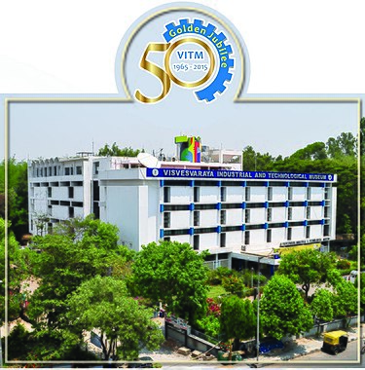

Fig:1.8(a) VMIT

This splendid museum, dedicated to the memory of Bharat Ratna M. Visvesvaraya, the architect of modern Karnataka, houses various technical inventions and offers you a glimpse of the history of technological development in the country. A major attraction here is a 1:1 scale replica of the Wright Brothers’ Flyer, the World’s first piloted aircraft and a ‘Flyer Simulator’ that offers a delightful experience to visitors. At the Dinosaur Corner, one can also witness the movement and sound of a life-sized animated Spinosaurus in a recreated environment.

**1.8.1:HISTORY:**

Honouring [Sir M. Visvesvaraya](https://en.wikipedia.org/wiki/M._Visvesvaraya), the All-India Manufacturers Organization and Mysore State Board decided to create a science and technology museum in Bangalore. The foundation stone was laid by [Shri B. D. Jatti](https://en.wikipedia.org/wiki/B._D._Jatti) , Chief Minister of Mysore, on 15 September 1958. The Visvesvaraya Industrial Museum Society (VIMS) came to be registered as the nodal agency in order to pool resources from various industrial houses. It was inaugurated by the first Prime Minister of India, [Pandit Jawaharlal Nehru](https://en.wikipedia.org/wiki/Pandit_Jawaharlal_Nehru), on July 14, 1962.

The first exhibition, 'Electricity', was opened to the public on July 27, 1965.

In the year 1970, VITM launched the Mobile/Moving Science Exhibition (MSE) with 24 participatory exhibits mounted on a bus. The MSE Bus travels throughout Southern India.

In 1978, many science museums, including VITM, parted from [CSIR](https://en.wikipedia.org/wiki/Council_for_Scientific_and_Industrial_Research) and were brought under a newly formed society registered on 4 April 1978 as National Council of Science Museums (NCSM). In 1979 an extension was added to the building, increasing the total area of the museum to 6,900 m2 (74,000 sq ft).

NCSM set up three additional science centres at [Gulbarga](https://en.wikipedia.org/wiki/Gulbarga) ([Karnataka](https://en.wikipedia.org/wiki/Karnataka)) in 1984, [Tirunelveli](https://en.wikipedia.org/wiki/Tirunelveli) ([Tamil Nadu](https://en.wikipedia.org/wiki/Tamil_Nadu)) in 1987, [Tirupati](https://en.wikipedia.org/wiki/Tirupati) ([Andhra Pradesh](https://en.wikipedia.org/wiki/Andhra_Pradesh))in 1993 and at Kozhikode, Kerala in 1997, which are functioning under the direct administrative control of VITM. Thus, VITM has become the southern zone headquarters of NCSM.

The museum attracts nearly one million visitors a year, and is open on all days (except [Deepavali](https://en.wikipedia.org/wiki/Deepavali) and [Ganesha Chaturthi](https://en.wikipedia.org/wiki/Ganesha_Chathurthi)) from 09:30 to 18:00.

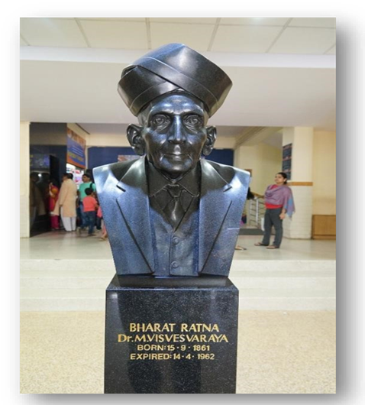

Fig 1.8.1-Dr.M.Visvesvaraya Statue

**1.8.2:GALLARY:**

**1.Visvesvaraya Museum Entrance:**

Stepping into the Visvesvaraya Industrial & Technological Museum is an entrancing journey into the realms of scientific marvels and technological innovations. The museum serves as a vibrant tapestry, intricately woven with exhibits that showcase the evolution of science and technology. Visitors are greeted with a chronological odyssey through the history of machinery, witnessing the transformation from rudimentary tools to sophisticated, high-tech systems. Interactive physics displays bring abstract principles to life, allowing hands-on exploration of concepts like gravity and electricity.

Robotics exhibits showcase the progression from early prototypes to advanced artificial intelligence, offering a glimpse into the future of automation. Aeronautics and aerospace displays transport visitors into the skies and beyond, while communication technology exhibits illustrate the incredible evolution from telegraph to the interconnected digital age.

The museum's dedication to education is epitomized in biotechnological showcases, shedding light on groundbreaking advancements in medicine and genetics. Industrial processes and automation exhibits provide insight into the optimization of manufacturing.

In this captivating environment, the wonders of science and technology are not just observed but experienced. The Visvesvaraya Industrial & Technological Museum stands as a testament to human ingenuity, inspiring a deep appreciation for the incredible progress that continues to shape our world.

**2.Engine Hall:**

The Engine Hall at Visvesvaraya Industrial and Technological Museum is a captivating space that celebrates the marvels of engineering and technology. Named after Sir M. Visvesvaraya, a distinguished engineer and statesman, the museum is in Bangalore, India. The Engine Hall was set up in the year 1994. Over 50 exhibits arranged across 1000 sq m explain the evolution of mechanisms, machines and devices that form the very foundation of modern technology.

It is a captivating showcase that delves into the evolution of engines and machinery pivotal to industrial and technological progress .

Upon entering, visitors are greeted by a diverse array of exhibits, spanning different eras and technologies. The hall displays various engines, including steam engines that powered factories during the industrial revolution, internal combustion engines that revolutionized transportation, and modern turbines used in aviation and power generation.

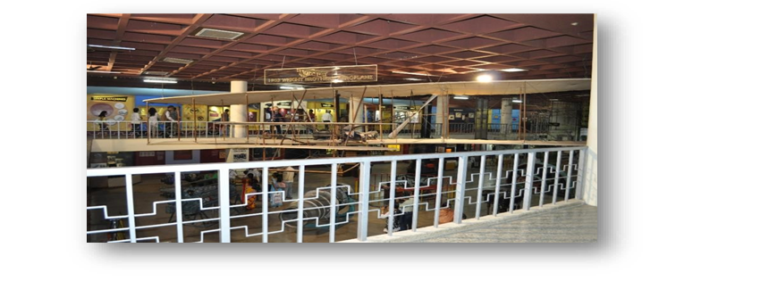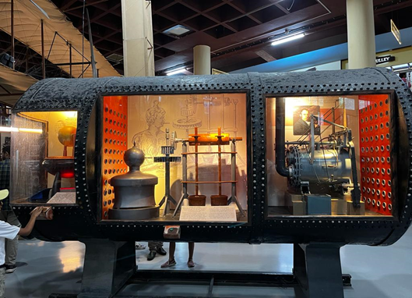

Fig:1.8.2(a) Engine hall Fig:1.8.2(b) Engine hall

Each exhibit is meticulously curated, offering detailed information about the specific engine's history, mechanics, and its impact on society and industry. Interactive displays, models, and informative panels provide an immersive experience, making complex engineering concepts accessible to all visitors, from enthusiasts to students and families.

The Engine Hall aims to educate and inspire curiosity about the development and significance of engines throughout history. It serves as an educationalplatform where visitors can witness firsthand the evolution of engines and appreciate their crucial role in shaping the modern world.

**3.FUN SCIENCE GALLERY:**

‘Fun Science’ Gallery was inaugurated on 23rd May 2008. The gallery set up in an area of 700 sq.mtrs has 66 exciting hands on exhibits.

The Fun Science Gallery at the Visvesvaraya Industrial and Technological Museum (VITM) is an engaging and interactive space designed to make science enjoyable and accessible for visitors of all ages. This gallery within the museum aims to ignite curiosity and foster a love for science through hands-on exhibits and demonstrations

Filled with interactive displays, puzzles, optical illusions, and engaging experiments, the Fun Science Gallery encourages visitors to explore various scientific principles in a playful manner. Visitors can engage in activities that demonstrate concepts related to physics, biology, mathematics, and more.

The exhibits are designed to stimulate the mind and provoke curiosity, allowing visitors to actively participate in experiments and learn through direct interaction. Whether it's understanding the laws of motion, experimenting with light and sound, or exploring the wonders of magnetism, the Fun Science Gallery offers an immersive experience that makes learning science an enjoyable adventure.

It's an excellent space for children, families, and school groups, providing a platform for experiential learning and fostering an appreciation for the wonders of science and technology. The emphasis on hands-on activities ensures that visitors not only learn scientific principles but also have fun while doing so.

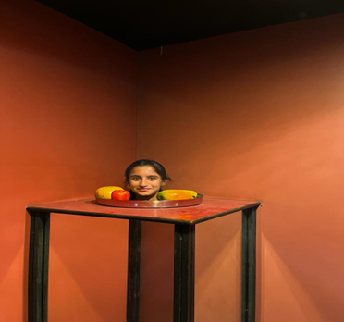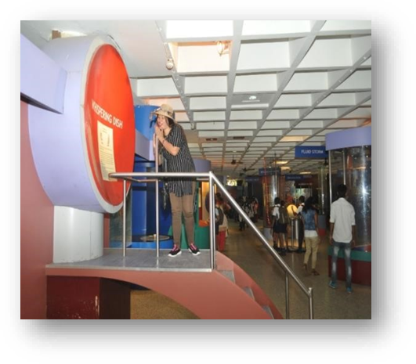

Fig:1.8.2(c) fun science Fig:1.8.2(d) fun science

**3.Electro Technical Gallery:**

The "Electrotechnic" gallery was thrown open to the visitors of the museum by Shri. Jawhar Sircar, Secretary, Ministry of Culture, Govt. of India on 8th April 2010. The gallery which has been set up in an area of about 780 sq. metre houses fascinating exhibits on various topics in electrical technology. The gallery is a journey through the spectacular world of electricity from the classical experiments to the state of art technology.

Filled with interactive displays, puzzles, optical illusions, and engaging experiments, the Fun Science Gallery encourages visitors to explore various scientific principles in a playful manner. Visitors can engage in activities that demonstrate concepts related to physics, biology, mathematics, and more.

The exhibits are designed to stimulate the mind and provoke curiosity, allowing visitors to actively participate in experiments and learn through direct interaction. Whether it's understanding the laws of motion, experimenting with light and sound, or exploring the wonders of magnetism, the Fun Science Gallery offers an immersive experience that makes learning science an enjoyable adventure.

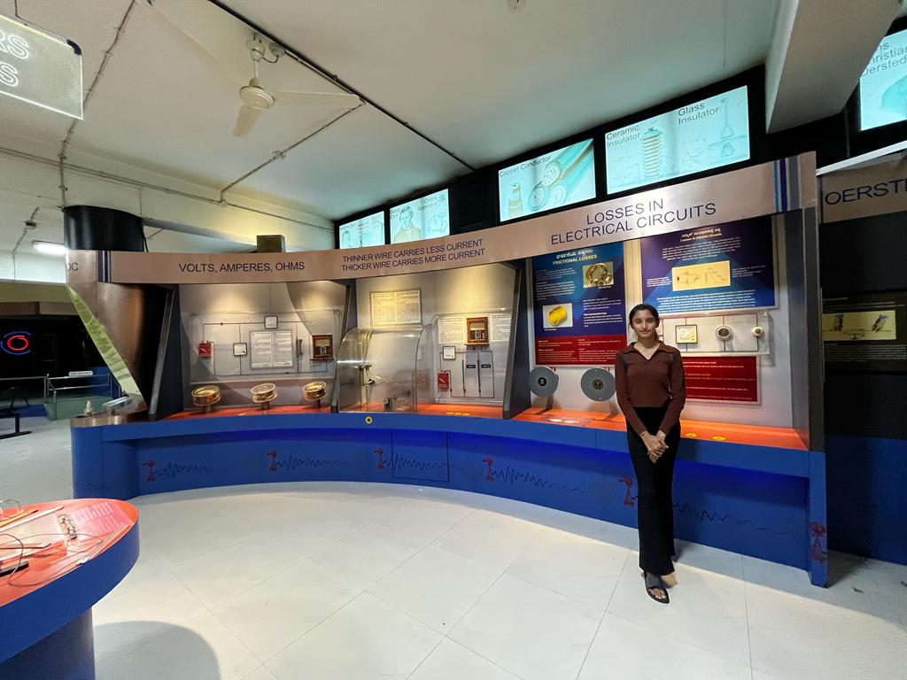

Fig:1.8.2(e) Electro Technical gallery

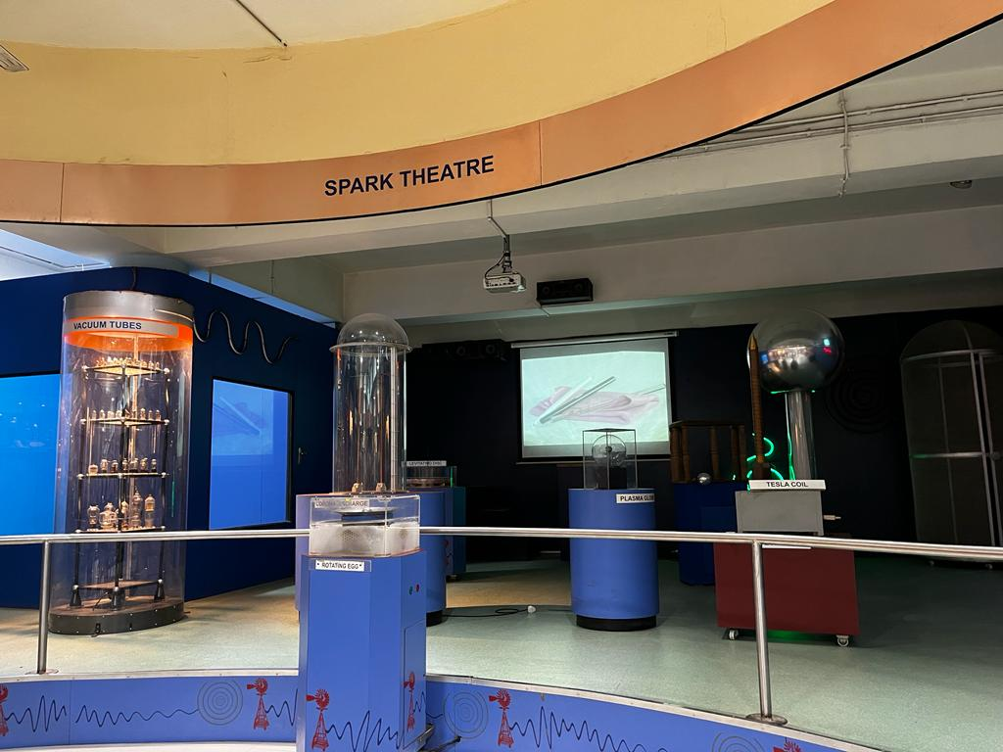

Fig:1.8.2(f) Spark Theatre

**4.Biotechnological Gallery:**

The Visvesvaraya Industrial and Technological Museum (VITM) primarily focused on various aspects of science, technology, and industry, including galleries showcasing fundamental scientific principles, engineering, and historical technological advancements.

The existence of a dedicated Biotechnological Gallery at VITM wasn’t prevalent up to that point. However, museums often undergo updates and expansions, introducing new galleries or themes to keep up with emerging technologies and changing educational needs. If the Biotechnological Gallery has been added after that time, I might not have specific details regarding its exhibits or inception.

The concept of a biotechnological gallery would likely focus on illustrating the principles and applications of biotechnology, covering areas such as genetic engineering, bioinformatics, healthcare advancements, agricultural biotechnology, and more. It would aim to educate visitors on the significant role biotechnology plays in various aspects of our lives.

If this gallery has been established since my last update, I recommend checking the latest information or contacting the VITM directly for specific details about the exhibits, themes, and the educational content featured within the Biotechnological Gallery.



Fig :1.8.2(g) Bio technology Fig:1.8.3(h)

**5.Space Technology Gallery:**

The “Space Technology” gallery was inaugurated by Shri. A S Kiran Kumar, Chairman, Indian Space Research Organisation (ISRO) on November 28th, 2017 at 3 P.M. in the presence of Dr. K Kasturirangan, Chairman National Education Policy & Chairman, Karnataka Jnana Ayog and Ms. Riddhi Mishra, Deputy Secretary (Museums) Ministry of Culture, Govt. of India. The gallery on Space Technology set up in an area on 700 sq. metres in the second floor of Visvesvaraya Industrial and Technological Museum, Bengaluru brings the various facets of Space Technology in an easy to comprehend way through several interactive and immersive exhibits.

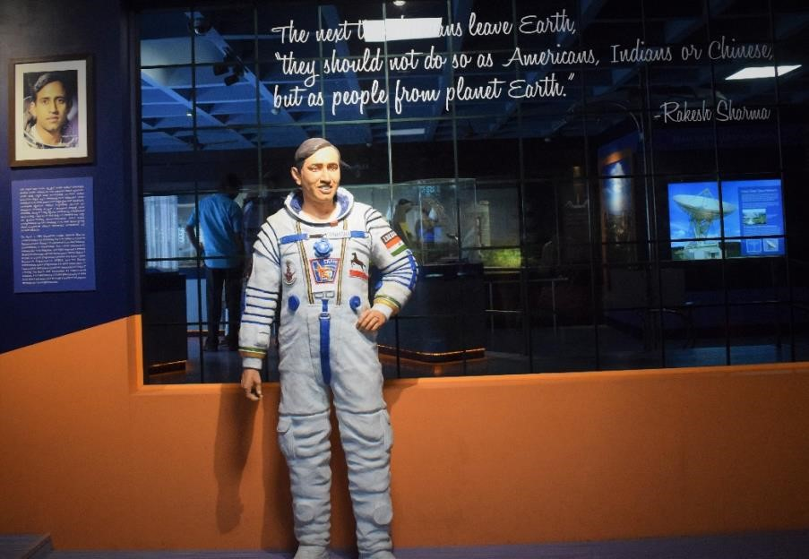

Fig:1.8.2(i) Sculpture of Rakesh Sharma

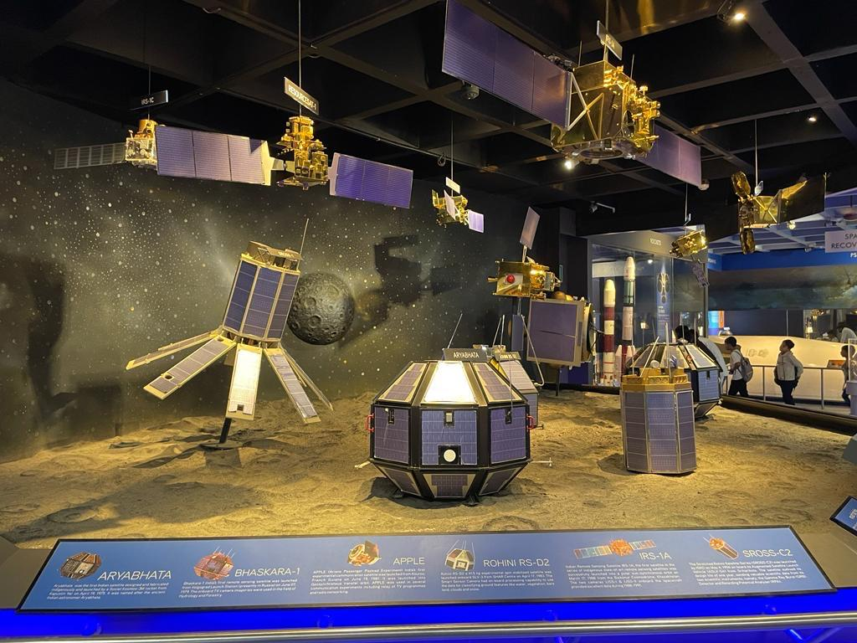

Fig:1.8.2(j) Space Technology Gallery

The Space Technology Gallery at Visvesvaraya Industrial and Technological Museum is an awe-inspiring journey through the cosmos, highlighting the marvels of space exploration and technology. This captivating gallery offers visitors a comprehensive and interactive experience, showcasing the advancements that have propelled humanity into the vast realm of outer space. As visitors enter the gallery, they are greeted by displays featuring the history of space exploration, from the early days of rocketry to the contemporary achievements of space agencies around the world. Engaging multimedia presentations provide insight into the challenges and triumphs of space missions, capturing the imagination of visitors of all ages. The Space Technology Gallery is likely to feature life-sized models of spacecraft, satellites, and rovers, allowing visitors to get up close and personal with the engineering marvels that have expanded our understanding of the cosmos. Interactive exhibits may simulate aspects of space travel, such as zero gravity environments or the experience of landing on other planets.

**6.Chandrayana-3:**

Chandrayaan-3 is India's ambitious lunar exploration mission, following the achievements of Chandrayaan-1 and Chandrayaan-2. Spearheaded by the Indian Space Research Organisation (ISRO), the mission is designed to continue the exploration of the Moon, emphasizing enhanced capabilities and technological advancements. Chandrayaan-3 aims to deploy a lander and rover on the lunar surface, conducting scientific experiments to deepen our understanding of Earth's celestial neighbour.

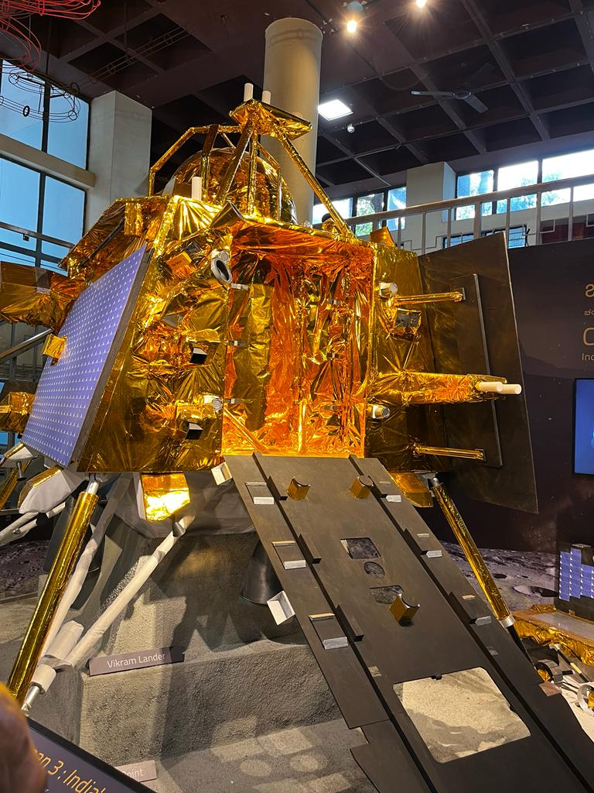

Fig:1.8.2(k) Chandrayan-3 model

The mission draws on the lessons learned from Chandrayaan-2 and incorporates improvements to ensure greater success. Chandrayaan-3 is expected to have an increased payload capacity, enabling more sophisticated scientific instruments and experiments. It represents a crucial step in India's space exploration endeavors, showcasing the nation's commitment to advancing its space capabilities and contributing valuable data to the global scientific community. The mission aligns with India's long-term space exploration goals, emphasizing both technological innovation and scientific discovery on the lunar landscape.



Fig:1.8.2(l) Chandrayan-3 model

**7.Wright Brothers aeroplane:**

The Wright brothers' aircraft at the Virginia Military Institute (VMI) is a replica of their original 1903 Wright Flyer. VMI's replica serves as a tribute to the pioneering aviation work of Orville and Wilbur Wright. It's meticulously constructed to replicate the design and mechanics of the original flyer, showcasing the historic significance of their achievements in aviation. The replica provides an opportunity for educational purposes, allowing people to experience and understand the groundbreaking technology and innovation behind the first powered flight.

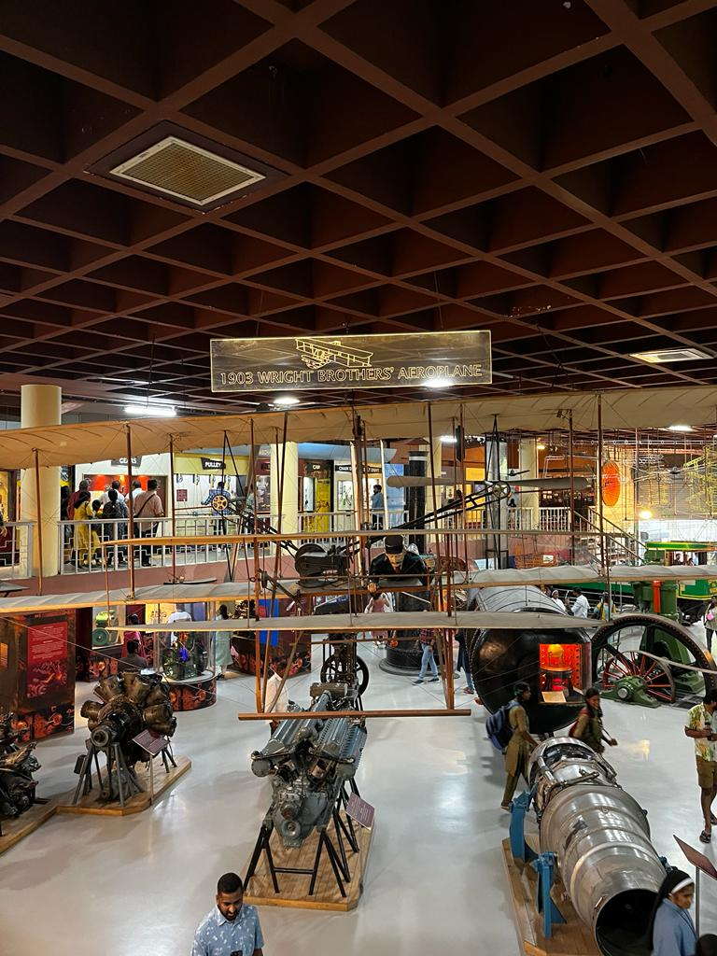

Fig:1.8.2(m)-Wright brothers aeroplane model

The Wright brothers built and flew the first successful powered airplane in 1903, making history with their innovative design and determination. Their aircraft, the Wright Flyer, made its historic flight at Kitty Hawk, North Carolina, achieving a distance of 120 feet in 12 seconds.

**8.Satellite Launching Station:**

India's primary satellite launching station is the Satish Dhawan Space Centre (SDSC), located on Srihari Kota Island in the Indian state of Andhra Pradesh. Named after Dr. Satish Dhawan, one of the pioneers of the Indian space program, the centre serves as the main launch site for the Indian Space Research Organisation (ISRO). The Satish Dhawan Space Centre has multiple launch pads, including the First Launch Pad (FLP) and the Second Launch Pad (SLP), each designed for specific types of launches. The FLP is primarily used for launching smaller vehicles, while the SLP is equipped to handle larger launch vehicles, including the Geosynchronous Satellite Launch Vehicle (GSLV) and the Geosynchronous Satellite Launch Vehicle Mark III (GSLV Mk III). GSLV Mk III, one of the most powerful rockets in ISRO's fleet, is instrumental in launching heavier payloads, including communication satellites and interplanetary missions like the Chandrayaan and Mangalyaan missions to the Moon and Mars, respectively.

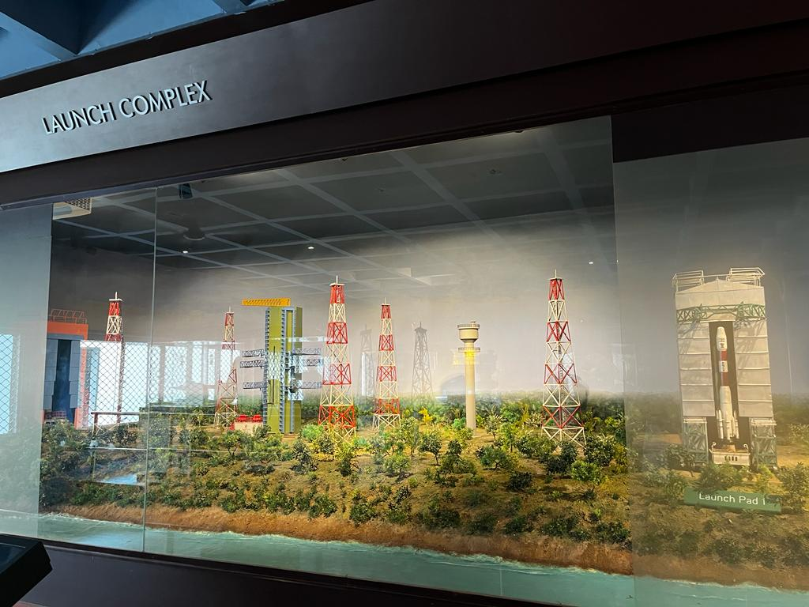

Fig:1.8.2(n) model of satellite launching station

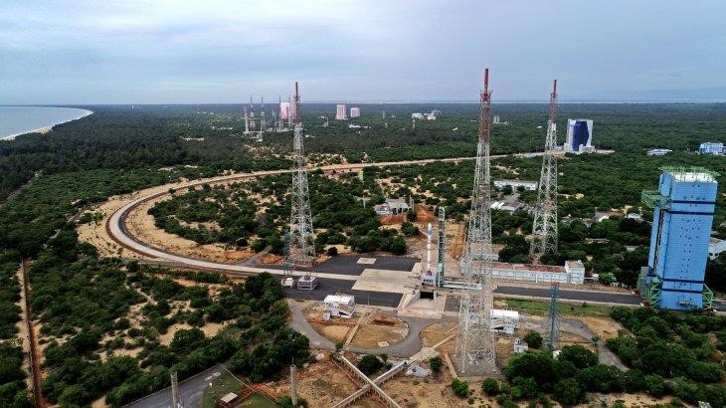

Fig:1.8.2(o)Satellite launching station, sriharikota,India

The Satish Dhawan Space Centre plays a crucial role in India's space exploration endeavors, providing a strategic base for the launch of satellites for communication, Earth observation, navigation, and scientific research. The center's geographic location on Sriharikota Island also enhances safety by providing a clear trajectory over the Bay of Bengal for rocket .

**1.8.3:Conclusion:**

The Visvesvaraya Industrial and Technological Museum (VITM) in Bangalore, India, stands as a testament to the visionary engineer Sir M. Visvesvaraya. Spanning various domains of science, technology, and innovation, the museum celebrates India's scientific heritage. Through its interactive exhibits, the VITM provides a hands-on learning experience, fostering curiosity and interest in visitors of all ages. It's a hub for exploration, housing displays on physics, electronics, aerospace, and other scientific disciplines, inspiring the pursuit of knowledge and discovery.

The museum serves as an educational resource, bridging the gap between theoretical knowledge and practical applications. Its efforts to engage visitors through workshops, demonstrations, and interactive sessions reflect a commitment to scientific literacy and technological advancement. The VITM encapsulates Visvesvaraya's ideals of innovation, ingenuity, and progress, inspiring future generations to contribute to India's scientific and technological landscape. It stands as a symbol of tribute to Sir M. Visvesvaraya's legacy and a beacon of inspiration for aspiring scientists, engineers, and innovators.

**1.9 Industry Visit (Rakuten)**

Rakuten Technology Conference

**Topic**: AI-nization

The Rakuten Technology Conference (RTC) of 2023, with the exciting theme “AI-nization” was conducted on November 18, 2023. It was the 15th edition of the event, the tech leaders, engineers, researchers and tech enthusiasts from around the world was gathered at the Bengaluru for talks and discussions on AI. The talks were to hear about the latest trends in technology.

The event was not only underscored Rakuten’s steadfast commitment to technological advancement but it also highlighted our pivotal role as pioneers and collaborators in shaping the future of the tech industry.

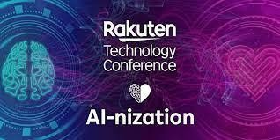

Fig 1.9

Guest Speakers:

1. Pankaj Rai, Chief Data Analytics Officer, Aditya Birla Group

2. Sameer Dhanrajani, CEO, AIQRATE

3. Goda Ramkumar, VP-Data Science, Swiggy

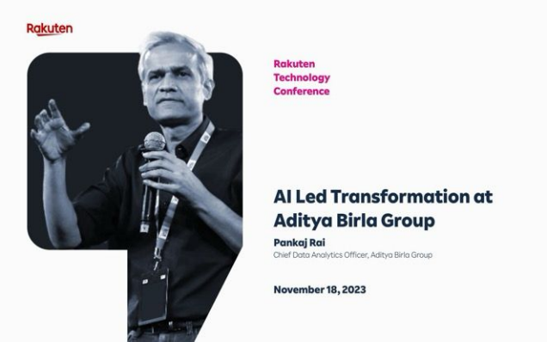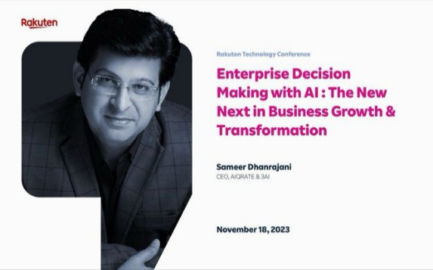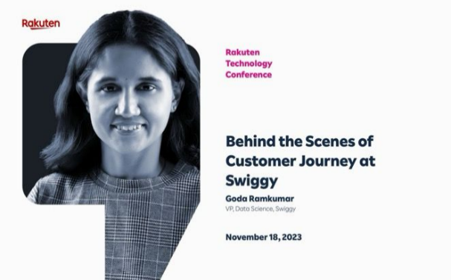

The agenda of the programme was divided into sessions:

## **Connect with the RTC Mainstage:**

The different branches of Rakuten from all around the world was connected with RTC mainstage in Japan. The opening remarks was conducted by Yasufumi Hirai, Group Executive Vice President, Chief of Staff to the CEO, Rakuten Group. Here the theme of the conference was discussed i.e., AI-nization where AI should be Augmented Intelligence defining as it is a subset of artificial intelligence in which AI technologies assist humans rather than replace them.

The clear vision was given about the difference between Augmented Intelligence and AI. Artificial intelligence (AI) is a self-learning technology that can mimic and replace human cognitive functions. Simply put, the machine takes the place of human intervention and contact. On the other hand, Intelligence Augmentation supplements human intelligence with AI to augment rather than replace it.

we were given top 10 strategic technology trends of 2024, and they are as follows:

1. AI trust, risk and security management.
2. Continuous threat exposure management.
3. Sustainable technology.
4. Platform Engineering.
5. AI-augmented development.
6. Industry cloud platforms.
7. Intelligent applications.
8. Democratized generative AI.
9. Augmented connected workforce.
10. Machine customers.

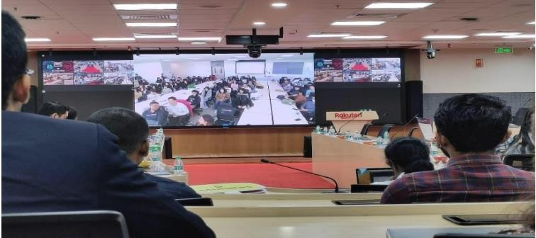

Fig 1.91

Example: If we've used Alexa, Siri, or another virtual assistant, you've used augmented intelligence. Virtual assistants don't make decisions for us. Instead, they provide the data when we need it.

And the sponsors for this great full event

**1.92 Welcome Note of AI-nization:**

The introduction about AI was given by Sunil Gopinath, CEO, Rakuten India. While a number of definitions of artificial intelligence (AI) have surfaced over the last few decades. John McCarthy offers the following definition “It is the science and engineering of making intelligent machines, especially intelligent computer programs”. The artificial intelligence was there before but OpenAI ChatGPT, DALL E-2 and Google Bard are revolutionary.defined.

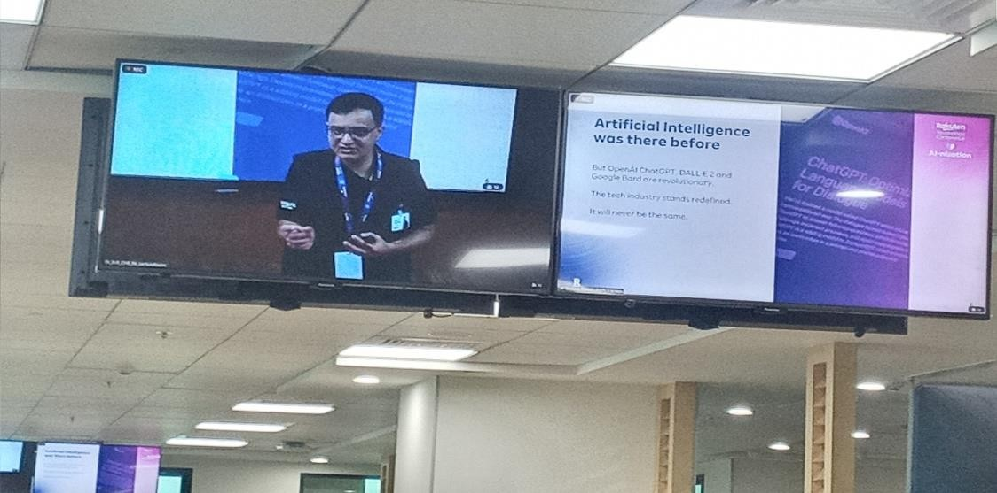

Fig 1.92

#### **Evolution of AI:**

Artificial Intelligence (AI) has transformed from a concept in the realm of science fiction to an everyday reality impacting every facet of our lives. The journey of AI has been marked by significant milestones and breakthroughs, each reflecting the convergence of theoretical foundations, technological advancements, and practical implementations. Here, we chronologically trace the evolution of AI, showcasing its most important developments.

#### **Pre-1950s: Theoretical Foundations**

The roots of AI can be traced back to antiquity, with philosophers attempting to explain the human mind as a symbolic system. However, the modern field of AI truly began to take shape in the mid-20th century.

* + **1843:** Ada Lovelace, known as the world's first computer programmer, proposed the idea that machines could manipulate symbols in addition to numbers, laying a fundamental concept for AI.
  + **1936:** Alan Turing proposed the concept of a "universal machine" (later known as the Turing Machine), a theoretical device that could solve any computation given enough time and resources. This forms the basis of the digital computer and the principle of computability.
  + **1943:** Warren McCulloch and Walter Pitts proposed the first mathematical model of a neural network, opening up the possibility of learning machines.
  + **1949:** Donald Hebb proposed a learning theory, now known as Hebbian learning, which became a fundamental concept in the development of artificial neural networks.

#### **2.1950s-1960s: Birth and Early Developments**

The field of AI was officially born in the mid-20th century, starting with the coining of the term "Artificial Intelligence."

* + - **1950:** Alan Turing proposed the Turing Test to determine a machine's ability to exhibit intelligent behaviour. In the same year, Claude Shannon published a paper on machine learning chess.
    - **1956:** The Dartmouth Conference officially coined the term "Artificial Intelligence." The participants, including John McCarthy, Marvin Minsky, Allen Newell, and Herbert Simon, became the leaders of AI research for several decades.
    - **1957:** Frank Rosenblatt invented the perceptron, the first artificial neuron.
    - **1958:** John McCarthy developed LISP, a programming language that became popular in AI research. LISP is a functional programming language that was designed for easy manipulation of data strings. As one of the oldest programming languages still in use, Lisp offers several different dialects and has influenced the development of other languages.
    - **1959:** Arthur Samuel developed a self-learning program to play checkers, demonstrating the power of machine learning.
    - **1965:** Joseph Weizenbaum created ELIZA, a natural language processing computer program, demonstrating the potential of AI in understanding and generating human language.

#### **3.1970s-1980s: AI Winter and the Rise of Expert Systems**

Despite the initial excitement, the lack of significant progress led to a period known as the "AI Winter. "The AI Winter was characterized by reduced funding and interest in AI research due to its failure to achieve its ambitious goals.

* + **1972:** Dendral, one of the first expert systems, was developed, marking a shift in AI research towards solving specific problems.
  + **1980:** The Japanese Fifth Generation Computer Systems project aimed to develop an "intelligent" computer, but ultimately it failed to meet its objectives.
  + **1986:** The backpropagation algorithm was reintroduced, leading to a resurgence in neural network research.

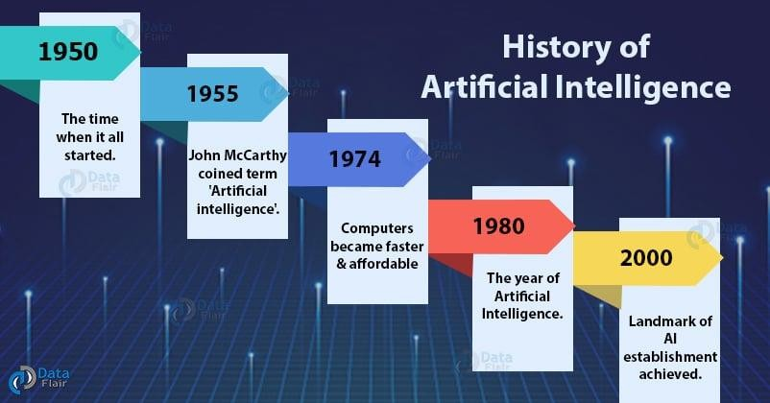

Fig 1.92.1

#### **4.1990s-2000s: The Internet Era and Machine Learning**

The advent of the internet provided a massive amount of data, fueling the development of machine learning algorithms.

* + **1997:** IBM's Deep Blue defeated world chess champion Garry Kasparov, marking a significant moment in the development of AI.
  + **1999:** Sony released AIBO, a robotic pet, demonstrating the capabilities of AI.
  + **2011:** IBM's Watson showcased the power of AI in understanding natural language by winning the TV quiz show Jeopardy, beating human champions.

**2016:** Google's AlphaGo program beat the world champion Go player, Lee Sedol, marking a significant milestone in AI's ability to learn and make decisions.

* + **2018:** The journey of Generative pre-trained transformers (GPT) began in this year when OpenAI, a leading AI company in the United States, introduced the first GPT model. This marked a significant milestone in the field of generative artificial intelligence.

#### **5.2020s: GPT-3 and Beyond**

* + **GPT Characteristics:** GPT models are a type of large language model (LLM) that utilise the transformer architecture. They are trained on vast amounts of unlabelled text data, which enables them to generate content that closely resembles human writing. As of 2023, most LLMs share these characteristics and are often broadly referred to as GPTs.
  + **GPT-n Series:** OpenAI has released a series of increasingly advanced GPT models, known as the "GPT-n" series. Each model in this series has been more capable than its predecessor, thanks to increases in size (number of trainable parameters) and training. These models have formed the foundation for more task-specific GPT systems, including models that are fine-tuned for following instructions. One such application of these models is the ChatGPT chatbot service.

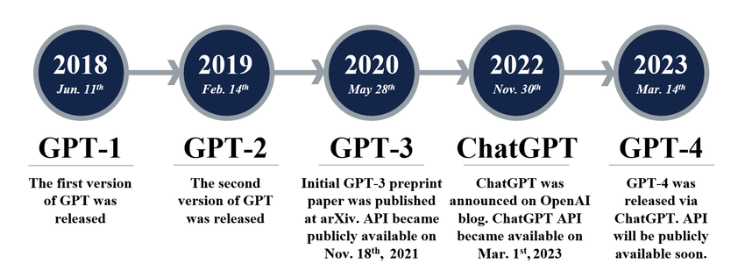

Fig 1.92.2

* + **GPT-4 March 2023:** The latest model in the series, GPT-4, was released. This model represents the current pinnacle of GPT development by OpenAI. It can process upto 25,000 words versus 4,000 with GPT-3.It is 40% more likely to generate accurate responses.
  + **Other GPT Models:** The term "GPT" has also been adopted by other organizations in their model names and descriptions. For instance, EleutherAI has created a series of GPT foundation models, and Cerebras has recently developed seven models. Additionally, companies across various industries have developed GPT models tailored to their specific needs. Examples include Salesforce's "Einstein GPT" for customer relationship management (CRM) and Bloomberg's "Bloomberg GPT" for finance.

#### **Future Developments**

* + **Launch Timeline:** The debut of GPT-5 is predicted to occur in 2024. Earlier ever, rumour’s about a 2023 release were refuted by Open AI's CEO, Sam Altman. Howa transitional model, GPT-4.5, is likely to be introduced by October 2023.
  + **Anticipated Capabilities:** GPT-5 is expected to exhibit less hallucination, making it more reliable. It's also predicted to be more efficient in terms of computation, which would lower the cost and duration of operating the model. It could potentially be a multisensory AI model, handling a variety of data types such as text, audio, images, videos, depth data, and temperature. Another anticipated feature is the support for long-term memory through a larger context length.
  + **Concerns about AGI:** There's a belief that GPT-5 might achieve Artificial General Intelligence (AGI), a form of AI that surpasses human intelligence. This has sparked worries about potential risks and the need for regulatory measures.
  + **OpenAI's Future Direction:** OpenAI has become more reserved about its operations and is less likely to share its models like GPT-4 or GPT-5 with the open-source community. However, reports suggest that OpenAI is developing a new open-source AI model for public release.

## **Everyone is talking about deploying AI!**

According to the Harvard Business Review “AI is most valuable when it is operationalized at scale. For business leaders who wish to maximize business value using AI, scale refers to how deeply and widely AI is integrated into an organization’s core product or service and business processes”.

* + The 35% of companies globally reported to be using AI in their business.
  + The 83% of organizations say that AI is top priority in their future business plans.

## **Rakuten’s AI-nization Plan**

1. **Vision:** The vision stands for augment human creativity with the power of AI.
2. **Strategy:** The base of the strategy is building a Solid Data Foundation with customer context, enterprise knowledge with Rakuten and world knowledge with OpenAI.
   * Leveraging Rakuten Channels with online and offline Ecosystem.
   * The drive growth with a rapid “Flywheel”. The cycle starts from AI first, then professionally reviewed and at last customer validation.
3. **Roadmap:** A roadmap is a strategic plan that defines a goal
   * Wave 1: Rapidly prototype to experiment, test, learn.
   * Wave 2: Focus on Rakuten AI for businesses and corporate functions.
   * Wave 3: Deliver consumer-facing AI services at scale.

## **Applied AI at Rakuten**

1. **Credit Scoring:** Customer Insights, Geo Data and Social Graph to improve predictability across bank, card, insurance.
2. **Super personalized recommendations in E-com:** Knowledge Graphs.
3. **Bioinformatics:** Leverage power of AI to analyze complex biological data including cancer cells, genome blood and tissue.
4. **Computer Vision:** It enables computers to interpret and analyze the visual world, simulating the way humans see and understand their environment.

## **GenAI at Rakuten**

1. **Intelligent ChatBots:** Mobile, Securities, Search.
2. **Creative AI:** Ad creatives and digital marketing, code generation
3. **Engineering:** No code/low code solutions democratize BI dashboard development.
4. **Customer Success**: AI chatbots with new features have emerged to improve the customer experience like chatbots that use machine learning to predict what a customer would help and provide proactive support.

## **1.93 AI Led Transformation at Aditya Birla Group**

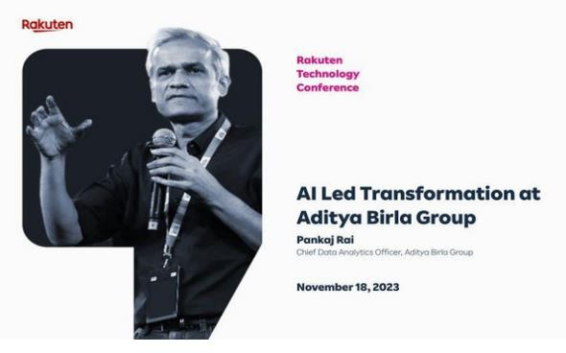

Fig 1.93

The next part of the session was held by guest speaker, Pankaj Rai, Chief Data Analytics officer, Aditya Birla Group. Pankaj Rai shared his insights on the importance of having a well-defined strategy to achieve success in life. He emphasized that a good strategy is essential for managing things and adapting to new technologies that are rapidly changing our lives. He also spoke about the finance and accounting area, strategy area, and economics area. Pankaj Rai’s experience in strategy consulting and financial services was evident in his discussion of data analytics and its role in decision-making. He shared how data- driven decision-making can help businesses gain a competitive edge. He also discussed his experience of working with Wells Fargo and how he established digital capabilities to enable the bank’s digital channels. Overall, Pankaj Rai’s session was an excellent opportunity to learn from a seasoned professional in the field of data analytics. His insights on strategy and data analytics were enlightening, and I am grateful for the knowledge I gained from his session.

#### **Key Insights:**

1. **Financial Guidance Beyond Numbers:** Mr. Rai's exploration of financial guidance was not confined to the numerical intricacies of balance sheets and investments. He delved into the psychological and emotional dimensions of financial decision-making, emphasizing the need for a comprehensive understanding. His anecdotes and real-life examples illustrated how financial wisdom goes beyond mere calculations to become a tool for achieving life's broader goals.
2. **Strategic Planning as a Life Skill:** The session seamlessly transitioned into the broader concept of strategic planning. Drawing parallels between corporate strategy and life choices, Mr. Rai provided tangible examples of how strategic thinking can empower individuals to navigate challenges effectively. This holistic approach positioned strategic planning not just as a business necessity but as a fundamental life skill.
3. **Adaptability in the Technological Epoch:** Mr. Rai's role as an AI engineer added a layer of relevance to the discussion on adaptability in the technological era. He shared personal experiences of witnessing and driving technological advancements. His message resonated strongly with the audience, urging aspiring professionals to not only embrace technological changes but also to see them as opportunities for personal and professional growth.
4. **Effective Handling of New Topics:** The session's focus on learning extended to the art of effectively handling new topics. Mr. Rai's insights offered a roadmap for acquiring knowledge in diverse domains such as finance, accounting, and economics. He emphasized the importance of curiosity, strategic engagement, and continuous learning, essential components for success in an ever-evolving academic and professional landscape.
5. **Harmony of Strategy in AI Engineering:** In a captivating segment, Mr. Rai seamlessly merged the discourse on strategy with the realm of AI engineering. He illuminated how strategic planning plays a pivotal role in the development and deployment of artificial intelligence. For those aspiring to navigate the complexities of cutting-edge technology, this intersection of strategy and AI engineering provided invaluable guidance

## **Enterprise Decision Making enable by AI: The new next in Business growth and transformation**

The fourth session was held by Sameer Dhanrajani, CEO, AIQRATE & 3AI.The session began with the topic AI & Analytics. The author for this edition is Sameer Dhanrajani.

#### **AI and Analytics:**

* + 1. We are ushering into an AI era-An algorithm driven economy where algorithms sit at the core of every business model, and in the organizational DNA.
    2. The first book of its kind in its genre, a must have primer for CXOs for curating, developing and executing AI strategies in their enterprises for end-to- end transformative impact. A valuable guide for executives and aspiring professionals on how AI can transform business, with deep focus on key industries and exponential technologies. The book also showcases the immense AI adoption and consumption scenarios in high impact and rapidly changing industries.

For example, starting with something which is a story, a real-life story. This is in a public domain and absolutely for the sayers of AI. We always keep on believing that AI is complex, not for the masses, and it's an expensive technology. Now this is a story of a gentleman in Japan.

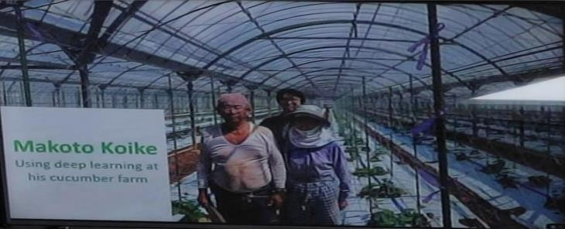

Fig 1.93.1

Makato Koyaki, the guy who's standing at the back of the picture, the young- looking guy. He's standing with his parents now in Japan. His parents are farmers, they're into agriculture. Cucumber again is an exotic variety in Japan, grown by about 89 variables as in shape, texture, colour, dimensions and all. And in one of the conversations with Macabu, his mother said our income over the years by growing cucumbers is going down and cucumber is sold in every market, let's stay fortnight in auction market. So, he had done a bit of analytics in his engineering days and he said maybe this is the best time, important a bit of knowledge to the extract. So he went back to his home, picked up his iPhone through the camera of the iPhone he clipped about 2500 pictures of the cucumbers in the cucumber farm. We can observe that there are different dimensions, different angles and can differentiate among them. He went back through Amazon. He purchased a Raspberry Pi 3 processor which can be bought at $3540 and there he enabled a Google Tensor Floating, which is known as an open source, freely available tool which can actually create algorithms. The idea was to label, annotate pictures and correlate with the option partners of the cucumbers and his intent was to create an algorithm which can go fewer times i.e,30% to 35%. He trades them on this until he reached about 77%. He told his parents what exact variety they should be. His parents said that 18 months down the line, his parent’s income went up by 400% and the cost associated of using AI was just

$35.So that's the magic what speakers keep on saying what AI becomes when it becomes mainstream and it's actually not that complex what it's made out to be.

#### **Algorithm Economy:**

* Democratization of AI and Data as a service (DaaS) will lead to creation of new marketplaces to buy and sell advanced analytics algorithms.
* Niche startups dealing with plug and play AI led algorithm portfolio and a service-oriented end to end approach to unravel intelligence and insights.
* Algorithm economy will consist of millions of algorithms, each one representing a piece of software code that solves a business problem or creates new opportunity.
* AI platforms will be defined by the sophistication of their algorithms.

#### **AI: The new normal in business strategy**

1. Reimagining Customer Experiences.
2. Innovating products & services.
3. Transforming Business.

#### **Decision making scale with AI: The Framework**

1. **Augument Intelligence:**
   * Bring data+algorithms+compute to every decision.
   * Use AI to make BI contextual, personalized and real time.
   * Find few signals in new data.

#### **Automate and learn:**

* + Never send a human to do a machine’s job.
  + Build learning systems.
  + Leverage unsupervised learning.

#### **Incorporate human behaviour:**

* + Reduce information overload.
  + Account for human biases.
  + “Nudge” the right behaviour.

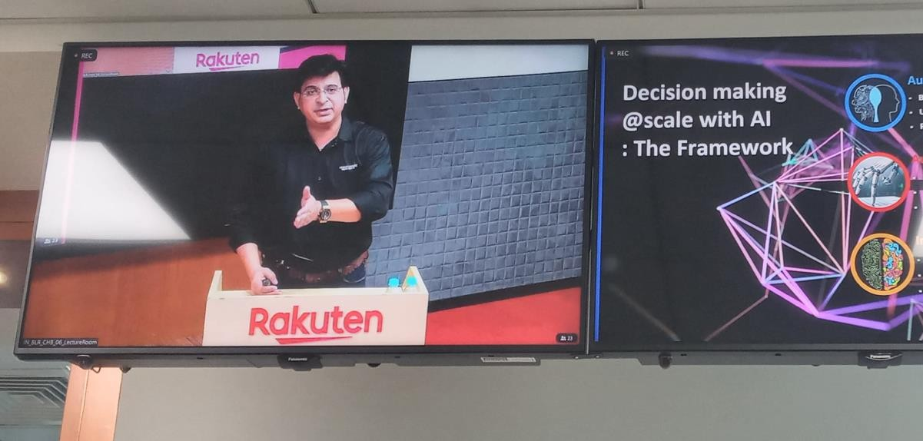

Fig 1.93.2

* + Sentiment analysis of analyst reports, earnings releases, corporate fillings.
  + Image processing to interpret body language of presenter.
  + Voice analytics to determine tone.
  + Satellite imagery to determine customer footfalls.
  + Nitrous oxide emitted by a manufacturer.
  + Women in management position.

#### **What can AI do for India?**

**Swachh Bharat Abhiyan:** AI, and specifically computer vision, can help substantially improve success of this GOI initiative:

* + - Help quickly identify areas of the country with low access to sanitation facilities.
    - Allow citizens to photograph and report broken/unclean/unusable sanitation facilities-this can be put through an AI bases system to access damage and speed up approvals for repair work.
    - In case of natural disasters, drone images could be used to survey areas affected and computer vision technology can again be used to assess damage and interventions required.

#### **Using Deep Learning to determine brand exposure from live stream videos**

* + Use deep learning to translate relative position and on-screen duration of logos into a structured data.
  + Potential to link this data to social media activity and utilize into marketing mix models.

The session ended by a thought given by Arthur C. Clarke “Any sufficiently advanced technology is indistinguishable from magic & AI is the magic”.

## **1.94 AI Demo Booth**

1. **LIP SYNC ALGORITHM:**

Virtual characters changed the way we interact with computers.

The underlying key for a believable virtual character is accurate synchronization between the visual (lip movements) and the audio (speech) in real-time. This work develops a 3D model for the virtual character and implements the rule-based lip-syncing algorithm for the virtual character's lip movements. We use the Jacob voice chatbot as the platform for the design and implementation of the virtual character. Thus, audio-driven articulation and manual mapping methods are considered suitable for real-time applications such as Jacob. We evaluate the proposed virtual character using hedonic motivation system adoption model (HMSAM) with 70 users. The HMSAM results for the behavioural intention to use is 91.74%, and the immersion is 72.95%.

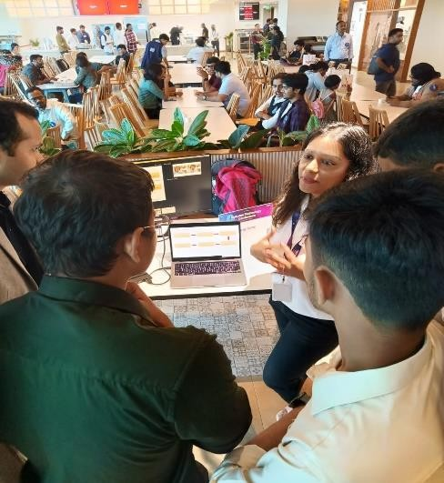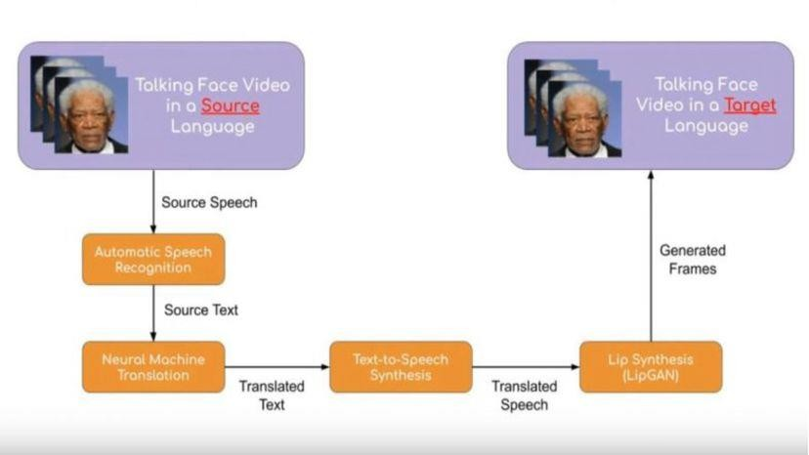

Fig 1.22

The average score for all aspects of the HMSAM is 85.50%. The rule-based lip- syncing algorithm accurately synchronizes the lip movements with the Jacob voice chatbot's speech in real-time.

#### **GEN AI 3D MODELLING**

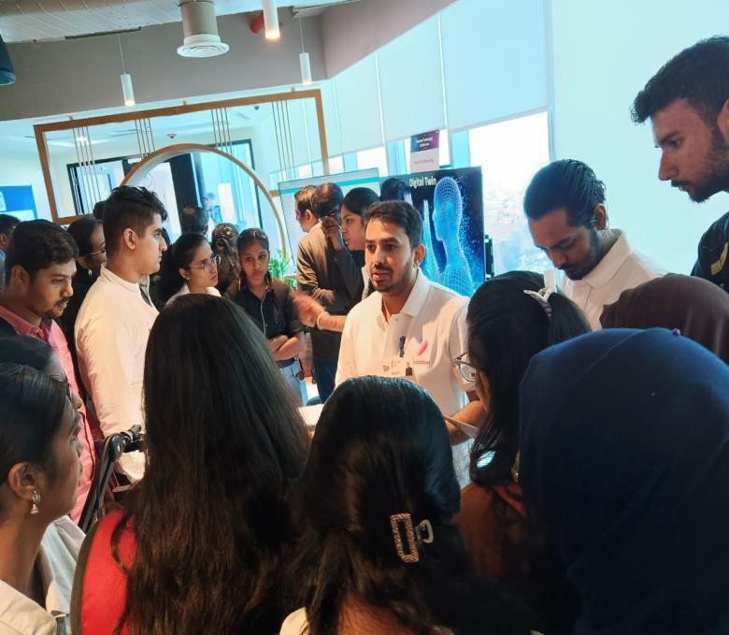Creating and visualizing 3D models has been made more accurate, accessible, and efficient through high-powered AI 3D object generators. Whether you’re a graphic designer or a game developer, it depends on your requirements as to which AI 3D object generators might be the best one for you. You can craft 3D models from scratch revolutionized using only images, text, or videos. We can craft 3D models from scratch revolutionized using only images, text, or videos.

Fig 1.94.1

#### **c) Personalised RTC Banner Generation**

Personalized Real-Time Communication (RTC) Banner Generation is a dynamic strategy that tailors digital banners to individual users or specific audience segments in real-time. This method is designed to elevate user engagement, boost conversion rates, and enhance overall user experience. The heart of this technology lies in its ability to harness advanced algorithms and artificial intelligence for dynamic content customization. By leveraging real-time data analysis, these systems can adapt and tailor banner content on-the-fly.A critical component of personalized RTC banner generation is the collection of user data. Ethical and consensual data gathering ensures the creation of user profiles that serve as the foundation for crafting personalized banners. This data encompasses user preferences, behaviour patterns, and demographic information. The dynamism of personalized RTC banners is maintained through real-time updates. Content is continuously adjusted based on user interactions, preferences, and other pertinent real-time data sources. This ensures that the content remains relevant and engaging, contributing to a more personalized user journey.

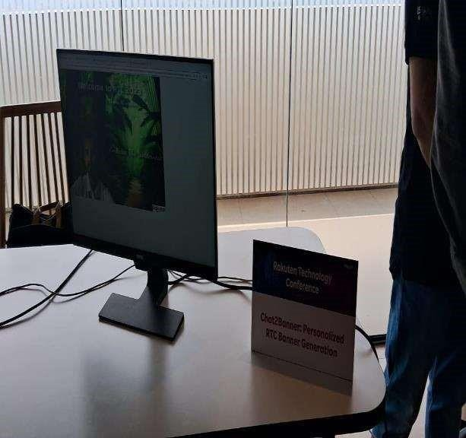Numerous industries have embraced personalized RTC banners with notable success. In e-commerce, for instance, personalized product recommendations significantly elevate user engagement and drive sales. These real-world applications underscore the versatility and effectiveness of personalized RTC banner strategies. However, like any technology, personalized RTC banner generation comes with challenges. Privacy concerns, data security, and ethical considerations in data usage must be carefully navigated. Striking a balance between personalization and user privacy is pivotal for the sustained success of this approach.

Fig 1.94.2

## **Food delivery times at Swiggy**

The last session was held by Goda Ramkumar, Vice President, Data Science, Swiggy.

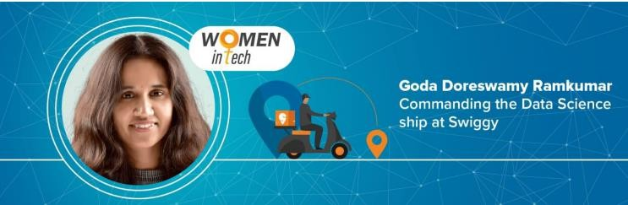

Fig 1.23

She emphasizes the critical role of accurately predicting food delivery times in the customer's decision-making process. She highlights the delicate balance required in setting customer expectations, as both delays and overly conservative delivery time estimates can impact customer satisfaction and order placement.

The accuracy of delivery time predictions extends beyond customer experience; it influences downstream systems within Swiggy, such as the assignment system and customer care ecosystem. To tackle the complex problem, Goda and her team employ a multi-input, multi-output (MIMO) deep learning model with entity embeddings. Elaborating further on solving delivery executive issues she says, “Let’s take a recent example, during the pandemic crowding around restaurants wasn’t allowed. So here’s where data science came into play, we had to work on controlling that issue.

Another instance is how we make sure that a DE is busy during their work hours. Most DE’s don’t like to be idle for long because it affects their goals, so we use data science to help them reach these targets.” Data science works wonders for companies, but Goda wants people to understand that it isn’t a “magic wand”. She says, “When it comes to data science there’s this expectation that it solves for everything and quickly. The biggest challenge is to set the right expectation of what data science can and cannot do in how much time. The models that you build, the data handling that you do, are all tools that have an impact on the business. But in order to make it really work, setting the right expectations and having the right strategy to collect the right data is essential”.

#### **Key Elements of Goda's Approach:**

1. **Entity Embeddings:** Goda leverages entity embeddings to encode categorical variables with high cardinality, efficiently capturing semantics and reducing dimensionality.
2. **MIMO Model Architecture:** The MIMO model handles multiple inputs and outputs, enabling the model to learn relationships between different aspects of the delivery process, such as order to assignment time, first mile time, wait time, last mile time, and order to reached time.
3. **Feature Considerations:** The features used in the model account for various factors influencing delivery times, including restaurant type, order size, kind of dishes, availability of delivery executives, and distance from the restaurant to the customer.
4. **Performance Improvements:** Goda's approach has led to significant improvements in model training efficiency and accuracy. The MIMO network design reduced training memory footprint by 50%, resulting in faster training times. The shared optimization of interdependent outcomes improved the mean absolute error (MAE) for order to assignment (O2A) predictions by nearly 30%, enhancing the efficiency of exception management systems.

Goda Ramkumar acknowledges the ongoing efforts to further enhance the model. This includes exploring custom loss functions tailored to business metrics and addressing challenges related to data sparsity and missing feature values across different cohorts.

In summary, Goda Ramkumar's innovative approach to predicting food delivery times at Swiggy involves a sophisticated combination of entity embeddings, MIMO model architecture, and feature-rich inputs. The results showcase improved accuracy and efficiency, laying the foundation for continued advancements in the field.

# Conclusion

The conference was ended by, a Vote of Thanks from Subbu Swaminathan, Senior Vice President, Product and Engineering, Rakuten India. He delivered his appreciation to all the chief guests, the staff and the delegate present over in the conference. He summarized the topic

AI-nization choose for the Rakuten Technology Conference 2023.

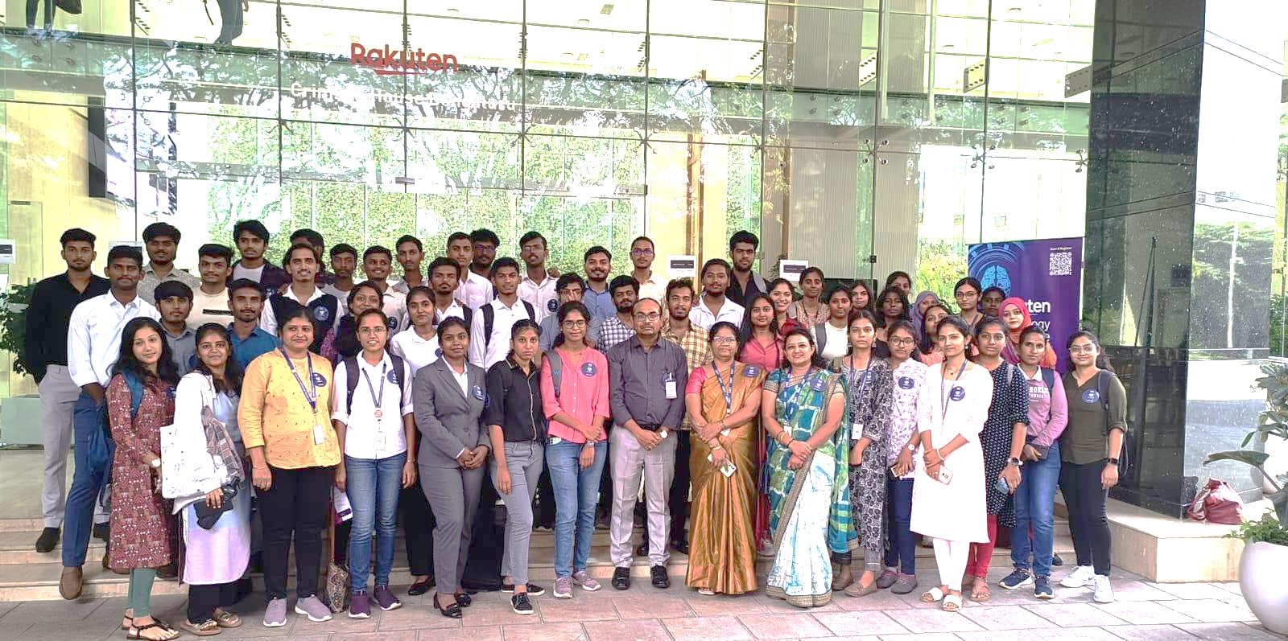We the student of Don Bosco Institute of Technology from CSE(AI&ML) Department was part of Rakuten Technology Conference 2023.

**Chapter-2 Awareness on Entrepreneurship**

**2.0 Introduction of Speaker**

Dr. Buvaneswari P, Professor and Head of the Department of Management Studies and Research at DBIT Bangalore, epitomizes excellence in academia and visionary leadership. Armed with a distinguished academic background in management, she has steered the department to new heights with her dynamic leadership. Her commitment to holistic education is evident in the fusion of theoretical knowledge and practical applications, ensuring students are well-equipped for the professional world.

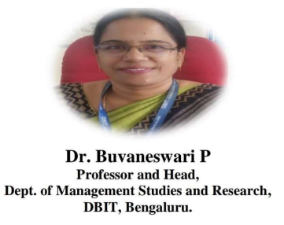

Fig 2.0

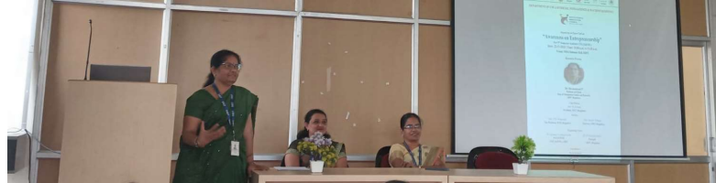In her role, Dr. Buvaneswari P has woven a tapestry of professional networks, ensuring that the department remains connected to industry trends and best practices. After the introduction to speaker the session was taken over by her. She started by questioning about Entrepreneurship and a Entrepreneur.

Fig 2.0.1

**2.1 Who is an Entrepreneur?**

* An entrepreneur is an individual who takes on financial risks in the pursuit of creating and managing a new business venture.
* Entrepreneurs are often characterized by their innovation vision, and willingness to embrace uncertainty.
* They may identify opportunities, develop business ideas, and organize resources to turn their vision into a reality.
* India has a rich history of entrepreneurship, and there are several famous Indian entrepreneurs who have made significant contributions to various industries.

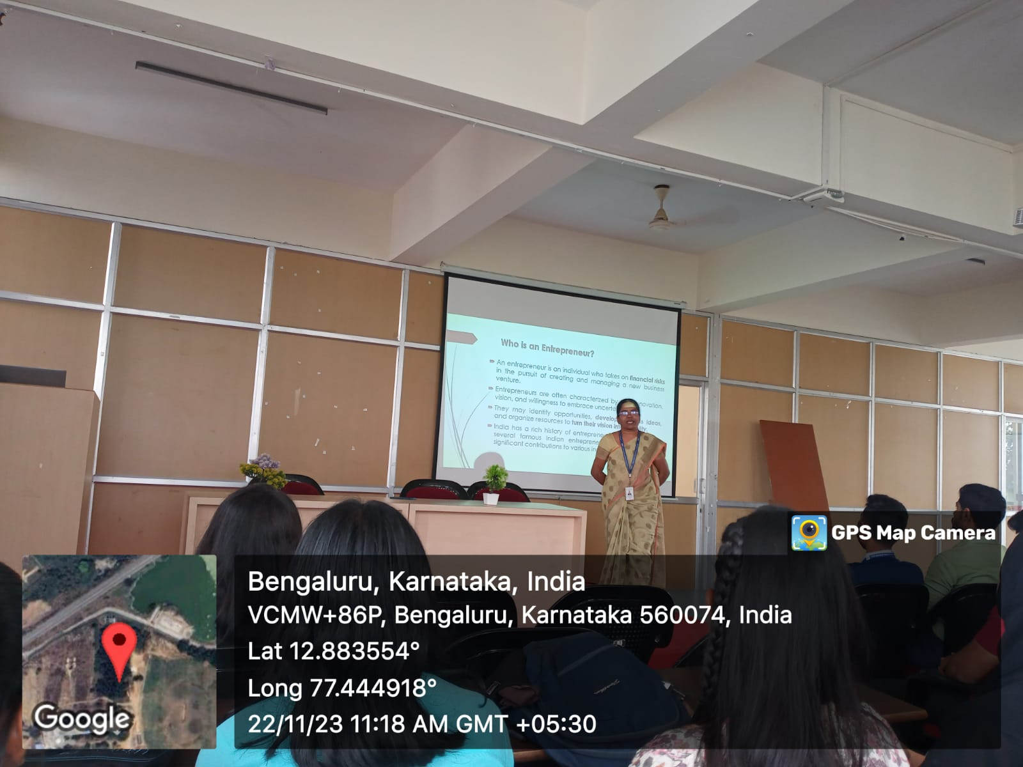

Fig 2.1

The word “entrepreneur” originates from a thirteenth-century French verb, entreprendre, meaning “to do something” or “to undertake.” By the sixteenth century, the noun form, entrepreneur, was being used to refer to someone who undertakes a business venture.

An entrepreneur is someone who starts or owns a business. Whether it's in farming, retail, manufacturing or in the service sector, entrepreneurs are businesspeople who find their success by taking risks.

Isabelle Bouchard quoted “Successful entrepreneurs surround themselves with people who can handle important tasks”.

Brian King quoted “The challenges is always coming up with an advantage over your competitor, and one that they just can’t immediately copy”.

**2.2 Examples of Famous Indian Entrepreneurs**

* **Mukesh Ambani:** The son of Dhirubhai Ambani, Mukesh Ambani is the Chairman and largest shareholder of Reliance Industries. Under his leadership, Reliance has expanded its presence in various sectors, including telecommunications with the launch of Jio.

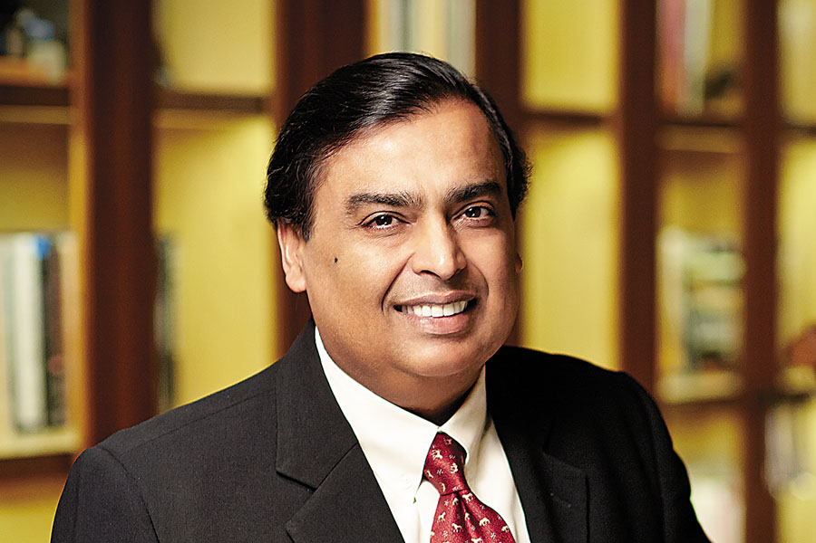

Fig 2.2 Mukesh Ambani

* **Shiv Nadar:** Founder of HCL (Hindustan Computers Limited), a leading global IT services company. Shiv Nadar is known for his contributions to the Indian IT sector and education through the Shiv Nadar Foundation.

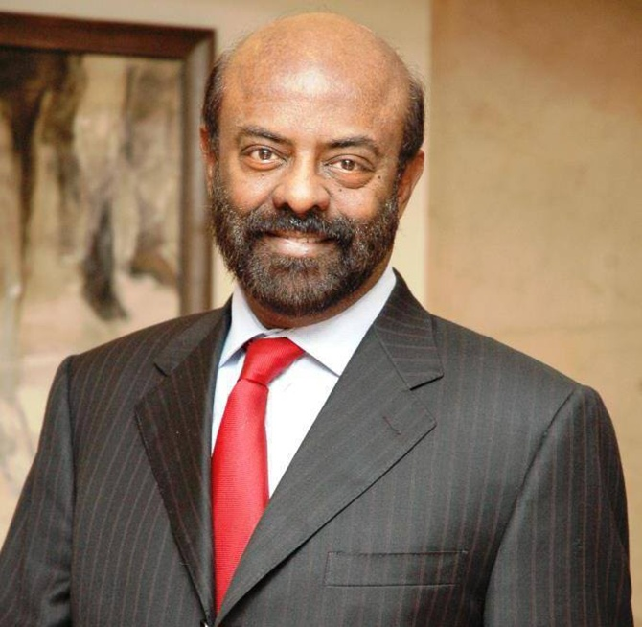

Fig 2.2.1 Shiv Nadar

* **Ratan Tata:** In 1990 he took the helm of Tata Group and ushered an array of reforms to modernised group's business methods to compete successfully in the new era. During his time, he brought all Tata companies under the one umbrella, acquired several comply produced car 'Indica' and first compact car ‘Nano’.

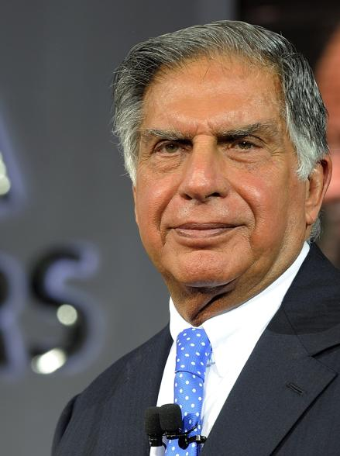

Fig 2.2.2 Ratan Tata

* **Anand Mahindra:** Chairman of the Mahindra Group, Anand Mahindra multinational Conglomerate with interests in various sectors, including automotive, agribusiness and IT services.

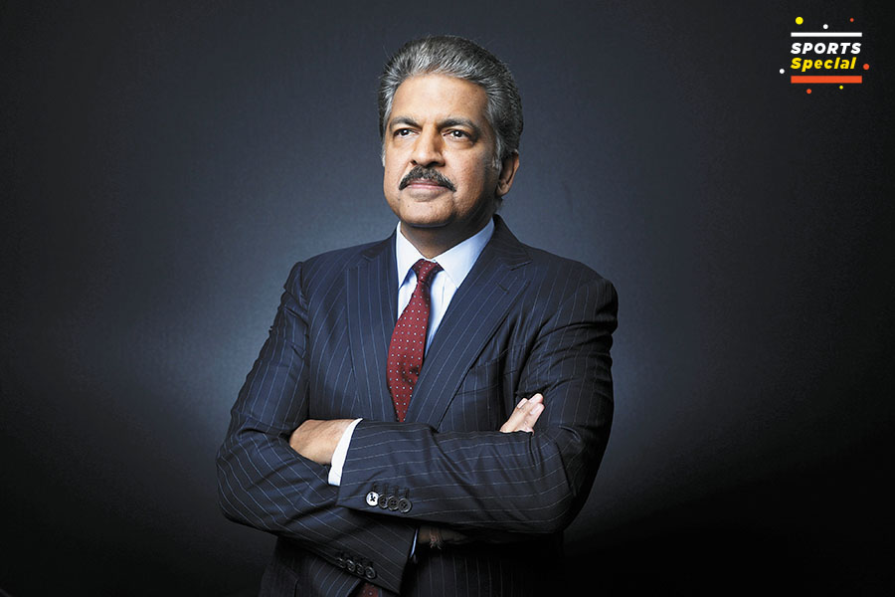

Fig 2.2.3 Anand Mahindra

**2.3 Characteristics and Qualities of an entrepreneurs**

Entrepreneurs are individuals who take on the challenge of starting and running their own businesses. They possess a unique set of characteristics and qualities that contribute to their success in the dynamic and often unpredictable world of business.

Here are some key traits commonly associated with successful entrepreneurs:

1. Visionary: Entrepreneurs have a clear vision of what they want to achieve. They can see opportunities where others may see challenges and are often driven by a long-term vision for their business. ¬ Risk-taking: Successful entrepreneurs are comfortable with taking calculated risks. They understand that entrepreneurship involves uncertainty and are willing to step out of their comfort zones to pursue opportunities.
2. Innovative: Entrepreneurs are creative and innovative thinkers. They are constantly looking for new ideas, solutions, and ways to improve existing products or services. This mindset helps them stay competitive in the market.
3. Resilient: Entrepreneurship involves facing setbacks and failures. Resilience is the ability to bounce back from challenges, learn from failures, and keep moving forward with determination.
4. Adaptable: The business landscape is constantly changing, and entrepreneurs need to adapt to new circumstances, technologies, and market conditions. Flexibility and adaptability are crucial qualities.
5. Passionate: Passion is a driving force for many entrepreneurs. A strong passion for their business and the work they do helps them stay motivated and overcome obstacles
6. Decision-making skills: Entrepreneurs need to make decisions quickly and effectively. They often face a multitude of choices, and the ability to make informed and timely decisions is critical to success.
7. Leadership: Entrepreneurs must be effective leaders to build and manage a team. Leadership involves inspiring others, setting a clear direction, and fostering a positive and productive work environment.
8. Proactive: Successful entrepreneurs are proactive in seeking out opportunities, solving problems, and addressing challenges before they escalate. They don't wait for things to happen; they make things happen.
9. Networking skills: Building a network of contacts is important for entrepreneurs. Effective networking can open doors to new opportunities, partnerships, and resources.
10. Financial literacy: Entrepreneurs need to have a basic understanding of finance to manage budgets, make financial projections, and ensure the financial health of their businesses.
11. Customer-focused: Entrepreneurs understand the importance of meeting customer needs. They are attuned to customer feedback, use it to improve their products or services, and build strong relationships with their customer base.
12. Time management: Entrepreneurs often wear multiple hats and juggle various responsibilities. Effective time management is crucial to prioritize tasks and focus on what matters most for the success of the business.

While these characteristics can contribute to entrepreneurial success, it's important to note that individuals may possess a combination of these traits to varying degrees. Additionally, entrepreneurship is a learning journey, and individuals can develop and enhance these qualities over time

**Entrepreneurial Mindset=Lifelong growth**

Having an entrepreneurial mindset will allow you to think, act, and perceive the world differently from the average worker, setting the foundation for success.

**2.4 How to think like an entrepreneur?**

* Independent -Honey bee
* Responsible - Hanuman
* Abundant-Karna
* Goal-oriented - Ambani
* Not afraid of failure - Thomas Alva Edison
* Growth oriented - Sony (Cooker to sound system)
* Feedback seeking - Conversation between Hanuman & Shukriva
* Learning oriented - Conversation between Krishna & Arjuna
* Forward-thinking-Sudha Murthy
* Self-accepting-Lord Gowthama Buddha
* Self-aware-Lord Gowthama Buddha
* Collaborative - Human & Vanara
* Courageour-Ravana

**2.5 How to develop an Entrepreneurial Mindset?**

A startup is a newly established business, typically characterized by innovation, scalability, and a pursuit of addressing a specific market gap. These ventures often operate in dynamic, fast-paced environments, aiming to bring a unique product, service, or solution to market. Startups are characterized by a high degree of uncertainty and risk, as they navigate uncharted territories, testing new ideas and business models. They frequently leverage technology and disruptive approaches to gain a competitive edge. Funding for startups often comes from angel investors, venture capitalists, or crowdfunding. The ultimate goal for startups is growth and, ideally, achieving profitability. The startup culture is marked by agility, adaptability, and a willingness to challenge conventional norms in the pursuit of innovation and market success.

**2.5.1 Four stage of startup**

* Idea
* Launch
* Growth
* Maturity

Each individual stage of this life cycle presents unique challenges that can be the difference between brilliance and mediocrity for any company.

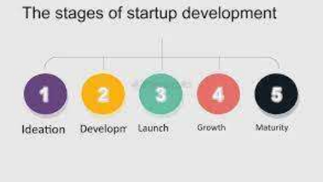

Fig 2.5.1

1. **Idea stage:** The first startup stage is evaluating your idea and finding the problem/solution fit. During this time, it is imperative to expand upon your idea and test the market to learn how prospects will perceive your idea. You can reach out to professionals in your area of interest and conduct problem/solution-fit interviews or focus groups. You can speak with people you believe to be your target audience. Ask them questions to learn how they view the problem you are trying to solve and what they are currently doing to address that problem (as your solution is not yet available!!). You can also bring in consultants and subject matter experts to help. Partnering with the right experts during the ideation phase of your startup has several benefits—they know the industry and market trends and can help you assess your ideal fit.
2. **Launch Stage:** The next stage in the lifecycle of your business is the Launch Stage. This is where you turn your idea into reality and launch it to the market. The first step of the Launch Stage is defining your product or service. You will need to use your best judgment combined with the research you did in the idea stage to decide what your product or service looks like. You can conduct some research to see how it will be received in the market. If you have a physical product, you can also measure the reaction of some initial consumers actually using your product. The second step in the Launch Stage is finding the market fit. Does your product or service “fit” or address a need in the market? You can survey prospects or the initial consumers from the first step above to understand how they feel about your offering. You can also talk to prospective customers to see how they will embrace the product. Use this information to evolve your product or service to better fit the needs of the market. The third step in the Launch Stage is finding the right message. In this step, you must define your product’s positioning in the market and in relation to your target users. Experiment with different messages in order for your target audience to uncover the value proposition of your product, product descriptions, and features and benefits. At this step, it is important you focus on what your targets and customers have to say about your product or service and how it is unique from others. The fourth step in the Launch Stage is evaluating the user experience. This is where you experiment with different elements of the user experience to reduce and remove points of confusion. This may involve testing and evolving various components of your offering, including the sales process and how potential and actual customers access your product or service. This might include an assessment of how your customers enter and walk around a physical location. Or, this could include how your customers navigate your website.
3. **Growth Stage:** When you reach the Growth Stage, it’s all about scaling your business. At this point, you’ve had a successful launch and are growing your user base. In the growth stage, your business should be focused on generating a consistent source of funds while also striving to reach new customers. Here, the biggest hurdle is dividing time between various demands that require your attention, such as identifying and pursuing new customers, managing increasing revenue, helping customers, evolving the product or service, administration of the business, outsmarting the competition, etc. You may need to begin finding people to help run or manage aspects of your business, which could mean hiring consultants or employees or outsourcing certain tasks. At Decimal, we help many clients at this stage in their business by allowing them to outsource their bookkeeping in order to give them more time to focus on more important tasks like identifying new customers and growing the business.
4. **Maturity Stage:** The last stage of the business lifecycle is Maturity. This is when you should be looking for new opportunities to expand. This might entail building more localized teams to adapt the product experience to each unique region, looking for acquisition opportunities that align with your product or mission, and, lastly, investing in your team and hunting for new growth channels. Just because the company has reached this stage does not mean that the risks and challenges no longer pose a threat. Continuing to focus on core competencies while keeping an eye on the market will help a business continue to operate successfully.

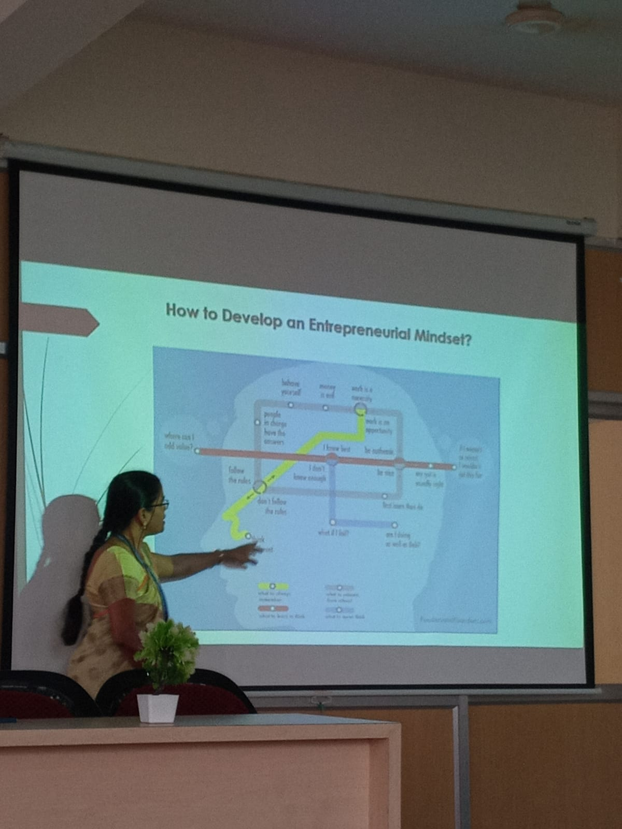.

Fig 2.5.1

**2.6 Types of Financial Assistance for Startup Businesses**

* Grants
* Loans
* Equity Investments
* Personal Savings
* Credit Cards
* Family and friends
* Crowd funding
* Government Programs
* Angel Investors

**2.6.1** **Various Incentives, Subsidies and Grants provided by Government of India**

* The Indian government offers various incentives, subsidies, and grants to promote economic growth, support specific industries, and encourage entrepreneurship.
* These programs aim to boost investment, create employment, and foster innovation.
* It's important to note that the availability and details of these incentives can change, and eligibility criteria may vary.
* Here are some examples of incentives, subsidies, and grants provided by the Indian government:

1. **Pradhan Mantri Mudra Yojana (PMMY):**

* Objective: Providing financial support to micro-enterprises in the form of loans.
* Beneficiaries: Small business owners, particularly those in the unorganized sector.

1. **Stand-Up India Scheme:**

* Objective: Encouraging entrepreneurship among women, SCs, and STs by providing loans for starting greenfield enterprises.
* Beneficiaries: Scheduled Castes (SCs), Scheduled Tribes (STs), and women entrepreneurs.

1. **Startup India:** 
   * + Objective: Fostering the growth of startups and promoting entrepreneurship.
     + Benefits: Tax exemptions, self-certification, and a Startup India Hub for mentorship and guidance.
     + Eligibility: Recognized startups with innovative solutions.
2. **Credit Linked Capital Subsidy Scheme (CLCSS):**

* Objective: Providing capital subsidy for technology upgradation of Micro, Small, and Medium Enterprises (MSMEs).
* Beneficiaries: MSMEs in the manufacturing sector.

1. **Export Promotion Capital Goods (EPCG) Scheme:** 
   * + Objective: Facilitating import of capital goods for the promotion of exports.
     + Benefits: Import duty exemption on certain capital goods.
     + Eligibility: Exporters with a specific export obligation.
2. **Make in India:**

* Objective: Encouraging domestic manufacturing and attracting foreign direct investment (FDI).
* Benefits: Various incentives for investors, simplification of procedures, and infrastructure support.

1. **National Manufacturing Competitiveness Programme (NMCP):**

* Objective: Enhancing the competitiveness of the manufacturing sector.
* Components: Technology upgradation, marketing assistance, quality management standards, and more.

1. **National Rural Livelihood Mission (NRLM):**

* Objective: Alleviating rural poverty by promoting self-employment and entrepreneurship.
* Components: Skill development, access to credit, and market linkages for rural entrepreneurs.

1. **Pradhan Mantri Employment Generation Programme (PMEGP):**

* Benefits: Subsidy for project costs and training assistance. Eligibility: Individuals, self-help groups, and registered institutions
* Objective: Generating employment opportunities in rural and urban areas through the establishment of micro-enterprises.

**2.6.2 Forms of Business Organization**

1. Sole Proprietorship
2. Partnership firm
3. Limited Liability Company (LLC)
4. Join Stock company
5. **Sole Proprietorship**

* Description: A business owned and operated by a single individual.
* Advantages: Simple to establish, complete control by the owner, and direct tax benefits.
* Disadvantages: Limited resources, unlimited personal liability, and potential difficulty in raising capital.

1. **Partnership firm**

* Description: A business owned by two or more individuals who share profits and liabilities.
* Advantages: Shared responsibilities, potential for more capital and skills, and simplified taxation (in the case of a limited liability partnership).
* Disadvantages: Shared profits, potential for conflicts among partners, and unlimited personal liability in general partnerships.

1. **Limited Liability Company (LLC)**

* Description: A flexible form of business organization that combines elements of a corporation and a partnership.
* Advantages: Limited liability for owners, flexibility in management, and pass-through taxation.
* Disadvantages: Complexity in some aspects, potential for disputes among members, and specific regulations varying by jurisdiction.

1. **Joint Stock Company**
   * A joint-stock company, also known as a corporation, is a form of business organization that is owned by shareholders.
   * It is a legal entity separate from its owners, and its ownership is represented by shares of stock.
   * Joint-stock companies are widely used for both small and large businesses and are known for providing certain advantages, such as limited liability for shareholders and ease of transferability of ownership

**2.7 Women Entrepreneur**

Women entrepreneurs, a dynamic force in the business world, contribute significantly to economic growth, innovation, and societal progress. Overcoming historical barriers, these trailblazers challenge stereotypes and redefine success. Their ventures span diverse sectors, from technology to sustainability, demonstrating the breadth of their impact. In addition to driving economic development, women entrepreneurs often prioritize social responsibility and community impact.

Many leads with a purpose, incorporating values of sustainability and inclusivity into their business models. Their ventures not only create jobs but also contribute to a more equitable and sustainable future. Despite progress, women entrepreneurs still encounter unique challenges, including limited access to funding and networks. Yet, their resilience in overcoming such obstacles is inspiring.

Networks and mentorship play crucial roles, fostering support and guidance that contribute to their success. Women entrepreneurs serve as powerful role models, inspiring future generations to pursue their entrepreneurial aspirations. Their stories highlight not only business acumen but also the importance of balance, advocating for work-life harmony. Recognizing the achievements of women entrepreneurs is vital, and numerous awards and initiatives now celebrate their contributions. As we champion diversity and inclusivity, the recognition of women entrepreneurs becomes integral to shaping a more innovative, equal, and prosperous global business landscape.

**2.7.1 Challenges faced by Women Entrepreneur**

* Access to Finance
* Societal Expectations and Stereotypes
* Networking Opportunities
* Work-Life Balance
* Market Access and Visibility
* Kills and Training Gaps
* Fear of failure
* Gender inequality
* Limited funding
* Lack of family support

**2.7.2 Examples of Women Entrepreneur**

1. **Name:** Vandana Luthra

**Company:** VLCC

**Industry:** Wellness and Beauty

**Achievements:** Vandana Luthra is the founder of VLCC, a wellness and beauty services company. She has played a key role in shaping the beauty and wellness industry in India.

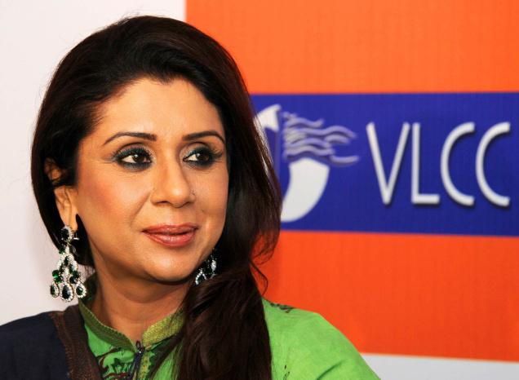

Fig 2.7.2

1. **Name:** Meena Bindra

**Company:** BIBA Apparels

**Industry:** Fashion and Apparel

**Achievements:** Meena Bindra is the founder of BIBA Apparels, a popular ethnic wear brand in India. She started BIBA to provide affordable and stylish ethnic clothing for women.

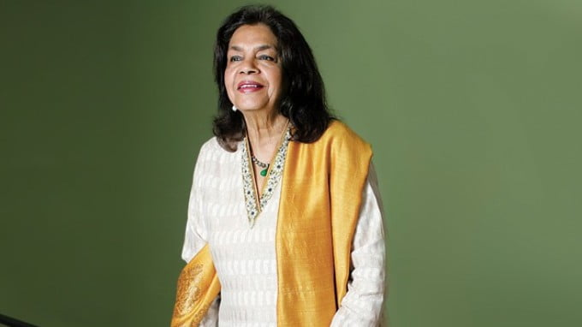

Fig 2.7.2.1

**2.8 Intrapreneur**

* An intrapreneur is an employee within a large corporation or organization who behaves like an entrepreneur but does so within the confines of that organization.
* In other words, an intrapreneur is someone who takes the initiative to develop and implement new business ideas or innovative projects within the existing structure of their employer.
* The term "intrapreneurship" combines "intra" (meaning within) and "entrepreneurship."
* Intrapreneurship can lead to the development of new products, services, or processes, fostering innovation within larger organizations.
* It is seen as a way for companies to stay competitive and responsive to market changes. Recognizing and nurturing Intrapreneurial spirit can be beneficial for both employees and the organization as a whole.
* The main difference between an entrepreneur vs. intrapreneur is that an entrepreneur starts their own company, whereas an intrapreneur works at a company that someone else founded. An entrepreneur develops a concept for a new business, which may include marketing products and services (or occasionally both).

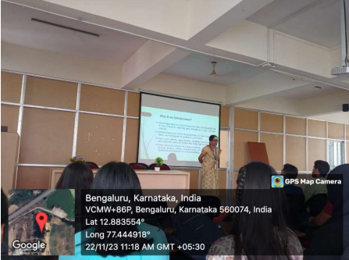

Fig 2.8

**2.8.1 Examples of Indian Intrapreneur**

1. 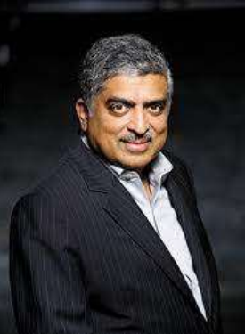**Nandan Nilekani:** Co-founder of Infosys and former chairman of the UIDAI, he has been involved in various initiatives that involve technology and innovation.

Fig 2.8.1

1. **Raguram Rajan:** While primarily known as an economist and the former Governer of the Reserve Bank of India, Raguram Rajan has been recognized for his innovative thinking and contributions to economic policy.

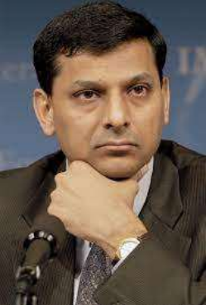

Fig 2.8.1.2

**2.9 Examples of Young Entrepreneurs**

1. **Name:** Aman Gupta

**Co:** boat lifestyle



Fig 2.9.1

1. **Name:** Vineetha Singh

**Co:** Sugar Cosmetics



Fig 2.9.2

1. **Name:** Vidit Aatrey

**Co:** Meesho

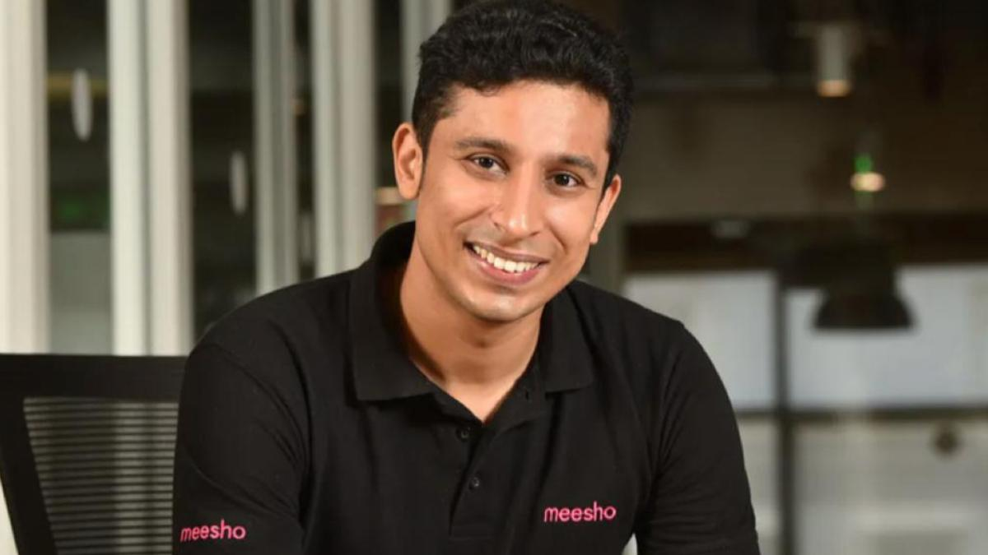

Fig 2.9.3

1. **Name:** Vijay Shekar Sharma

**Co:** Paytm



Fig 2.9.4

**2.10 Conclusion**

The term entrepreneur not only refers to the creator, owner and manager of a business, but also to the project leader of a business. To define the entrepreneur, two problems relating to the behaviour of economic agents must be combined: methodological individualism, according to which economic agents are calculators, and the theory of resource potential, according to which the rationality of economic agents is embedded in a network of social relationships. In other words, the entrepreneur is an economic agent whose ultimate goal is to create a business from a well-defined project. To realize his project, he mobilizes a number of resources (knowledge-based, financial and relationship-based), from which he produces other resources (employment, innovation, etc.), interacting with his environment. In this sense, the entrepreneur is rational, because he maximizes his resources in order to achieve a goal, which is to create his own job. In this sense, his behaviour is opportunistic, because he seeks to take advantage of all the opportunities presented to him (a social relationship, a grant, a requirement, etc.).

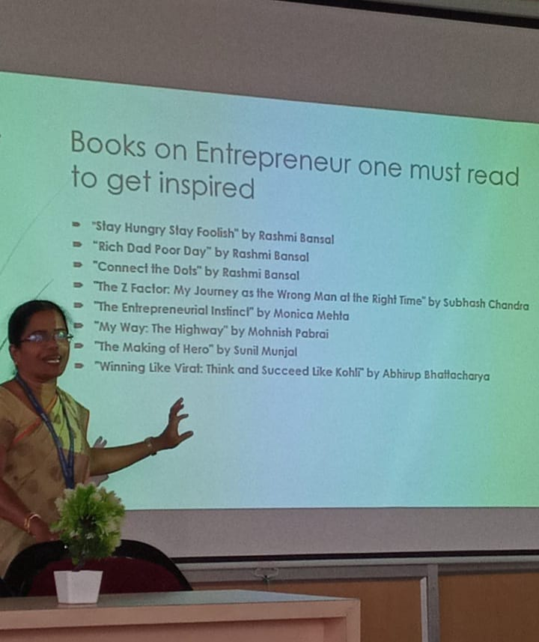 Entrepreneurship is a mind-set, an attitude; it is taking a particular approach to doing things. The motivations for becoming an entrepreneur are diverse and can include the potential for financial reward, the pursuit of personal values and interests, and the interest in social change. At the end of the session, the book to be read as Entrepreneur was discussed.

Fig 2.10

**Chapter:3 INTERNSHIP’S SOCIETAL ACTIVITY**

**Topic: AI and its applications**

**Introduction –**

**Initially introduction was given to the students on the Artificial Intelligence by the following key points –**

* The capability of a machine to imitate intelligent human behavior.
* Artificial intelligence (AI), the ability of a digital computer or computer-controlled robot to perform tasks commonly associated with intelligent beings. The term is frequently applied to the project of developing systems endowed with the intellectual processes characteristic of humans, such as the ability to reason, discover meaning, generalize, or learn from past experience.
* By Al we mean anything that makes machines act more intelligently. Our work includes basic and applied research in machine learning, deep question answering, search and planning, knowledge representation, and cognitive architectures

**Facts and Figures:**

* According to Statista, revenue from the Artificial Intelligence (AI) software market worldwide is expected to reach 126 billion dollars by 2025.As per Gartner, 37% of organizations have implemented AI in some form. The percentage of enterprises employing AI grew 270% over the past four years.
* According to Servion Global Solutions, by 2025, 95% of customer interactions will be powered by AI.
* A recent 2020 report from Statista reveals that the global AI software market is expected to grow approximately 54% year-on-year and is expected to reach a forecast size of  USD $22.6 billion.

**Students were very excited to hear about topic and listened to the explanation very keenly**

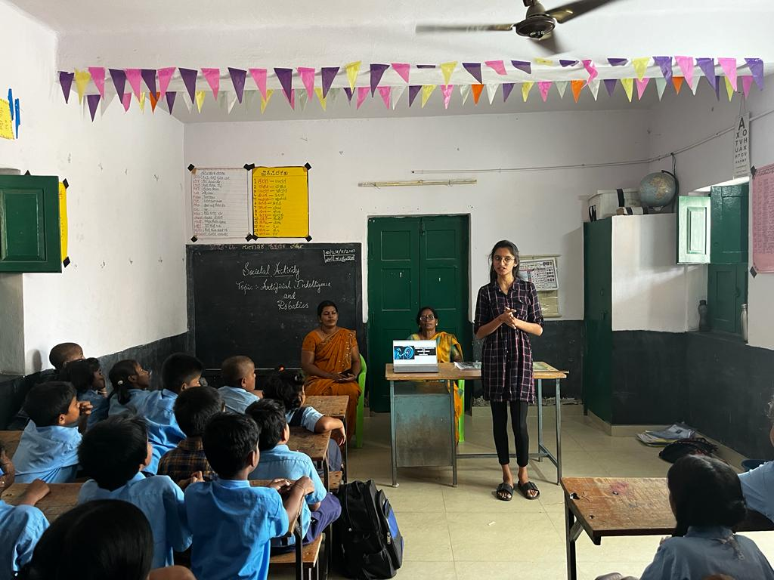

Fig(a):Doddmallur, channapatna

**Applications of Artificial Intelligence:**

**1. VOICE ASSISTANCE AND AI POWERED-ASSISTANCE:**

Chatbots help improve the user experience while shopping online. Natural Language Processing is used to make the conversation sound as human and personal as possible. Moreover, these assistants can have real-time engagement with your customers.

It's software that carries out everyday tasks via voice command. It's brings AI and machine learning together to recognize our voice and do what we ask it. Voice assistant software can be found on smart speakers, smartwatches, mobile phones, tablets and other devices

**EX: Apple’s SIRI, MICROSOFT CORTANA,GOOGLE ASSISTANT,AMAZON ALEXA**

**2.Application of AI in Education:**

Digitization of content like video lectures, conferences, and textbook guides can be made using Artificial Intelligence. We can apply different interfaces like animations and learning content through customization for students from different grades. Artificial Intelligence helps create a rich learning experience by generating and providing audio and video summaries and integral lesson plans.

* Classroom/Behavior Management
* Lesson Planning
* Classroom Audio-Visual
* Parent-Teacher Communication

**3.Applications of AI in lifestyle:**

Filters

The email that we use in our day-to-day lives has AI that filters out spam emails sending them to spam or trash folders, letting us see the filtered content only. The popular email provider, Gmail, has managed to reach a filtration capacity of approximately 99.9%.

Facial Recognition

Our favorite devices like our phones, laptops, and PCs use facial recognition techniques by using face filters to detect and identify in order to provide secure access. Apart from personal usage, facial recognition is a widely used Artificial Intelligence application even in high security-related areas in several industries.

**4.Applixations of AI in Healthcare:**

Artificial Intelligence finds diverse applications in the healthcare sector. AI applications are used in healthcare to build sophisticated machines that can detect diseases and identify cancer cells. Artificial Intelligence can help analyze chronic conditions with lab and other medical data to ensure early diagnosis. AI uses the combination of historical data and medical intelligence for the discovery of new drugs.

Ex: Dystropy

**5.Applications of AI in Automobiles:**

Artificial Intelligence finds diverse applications in the healthcare sector. AI applications are used in healthcare to build sophisticated machines that can detect diseases and identify cancer cells. Artificial Intelligence can help analyze chronic conditions with lab and other medical data to ensure early diagnosis. AI uses the combination of historical data and medical intelligence for the discovery of new drugs.

Automobile manufacturing companies like Toyota, Audi, Volvo, and Tesla use machine learning to train computers to think and evolve like humans when it comes to driving in any environment and object detection to avoid accidents.

**Ex: Self driving cars**

**CONCLUSION:**

Internships play a pivotal role in societal activity, acting as a bridge between academia and the professional world. These experiences offer invaluable opportunities for individuals to gain practical skills, insights, and hands-on experience in their chosen field. They serve as a cornerstone for career development, allowing individuals to test their interests and refine their career trajectories.

Internships also contribute to the overall economic landscape by supplying a skilled workforce to industries and fostering innovation through fresh perspectives and ideas. They enable companies to identify and nurture talent while benefiting from the energy and creativity of young minds.

Moreover, internships promote social mobility by providing access to learning experiences and networks that might otherwise be inaccessible. They contribute to the diversification of the workforce, fostering inclusivity and representation across various industries.

However, challenges such as unpaid internships and unequal access to opportunities highlight the need for greater equity in internship programs. Addressing these disparities is crucial in ensuring that internships serve as a vehicle for societal advancement and equal access to professional growth for all individuals.

**Summary:**

Internships serve as vital stepping stones for individuals transitioning from academia to the professional world. They offer hands-on experience, allowing participants to apply theoretical knowledge to real-world scenarios. These opportunities foster skill development, enhance resumes, and provide a glimpse into various industries, aiding in informed career decisions.

Internships represent a crucial facet of societal activity, bridging the gap between education and professional spheres. They facilitate the development of skills, knowledge, and practical experience for individuals entering the workforce. These programs contribute to the economy by supplying industries with a skilled labor force and fostering innovation through diverse perspectives.

Entrepreneurial internships are dynamic opportunities that combine the realms of entrepreneurship and traditional internships. They offer individuals a chance to immerse themselves in the entrepreneurial ecosystem, gaining firsthand experience in startup environments. These internships provide exposure to the fast-paced and innovative world of startups, allowing interns to contribute directly to a company's growth and development.

Participants in entrepreneurial internships often experience a steep learning curve, as they are exposed to various facets of business operations, from ideation to execution. They learn to navigate ambiguity, take on multifaceted roles, and develop a strong entrepreneurial mindset, fostering creativity, adaptability, and problem-solving skills.